2.3. Clustering

[Clustering](https://en.wikipedia.org/wiki/Cluster_analysis) of unlabeled data can be performed with the module **[sklearn.cluster](https://scikit-learn.org/stable/api/sklearn.cluster.html" \l "module-sklearn.cluster" \o "sklearn.cluster)**.

Each clustering algorithm comes in two variants: a class, that implements the fit method to learn the clusters on train data, and a function, that, given train data, returns an array of integer labels corresponding to the different clusters. For the class, the labels over the training data can be found in the labels\_ attribute.

**Input data**

One important thing to note is that the algorithms implemented in this module can take different kinds of matrix as input. All the methods accept standard data matrices of shape (n\_samples, n\_features). These can be obtained from the classes in the **[sklearn.feature\_extraction](https://scikit-learn.org/stable/api/sklearn.feature_extraction.html" \l "module-sklearn.feature_extraction" \o "sklearn.feature_extraction)** module. For **[AffinityPropagation](https://scikit-learn.org/stable/modules/generated/sklearn.cluster.AffinityPropagation.html" \l "sklearn.cluster.AffinityPropagation" \o "sklearn.cluster.AffinityPropagation)**, **[SpectralClustering](https://scikit-learn.org/stable/modules/generated/sklearn.cluster.SpectralClustering.html" \l "sklearn.cluster.SpectralClustering" \o "sklearn.cluster.SpectralClustering)** and [**DBSCAN**](https://scikit-learn.org/stable/modules/generated/sklearn.cluster.DBSCAN.html#sklearn.cluster.DBSCAN) one can also input similarity matrices of shape (n\_samples, n\_samples). These can be obtained from the functions in the **[sklearn.metrics.pairwise](https://scikit-learn.org/stable/api/sklearn.metrics.html" \l "module-sklearn.metrics.pairwise" \o "sklearn.metrics.pairwise)** module.

2.3.1. Overview of clustering methods

[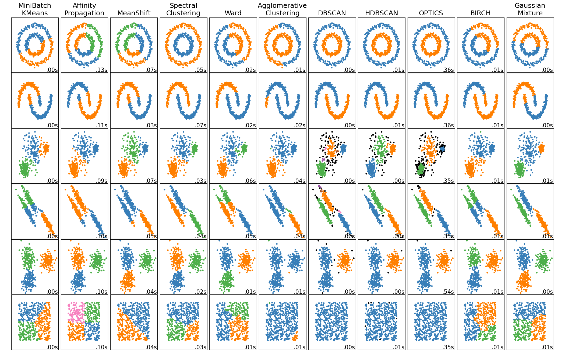](https://scikit-learn.org/stable/auto_examples/cluster/plot_cluster_comparison.html)

A comparison of the clustering algorithms in scikit-learn

| **Method name** | **Parameters** | **Scalability** | **Usecase** | **Geometry (metric used)** |
| --- | --- | --- | --- | --- |
| [K-Means](https://scikit-learn.org/stable/modules/clustering.html#k-means) | number of clusters | Very large n\_samples, medium n\_clusters with [MiniBatch code](https://scikit-learn.org/stable/modules/clustering.html" \l "mini-batch-kmeans) | General-purpose, even cluster size, flat geometry, not too many clusters, inductive | Distances between points |
| [Affinity propagation](https://scikit-learn.org/stable/modules/clustering.html#affinity-propagation) | damping, sample preference | Not scalable with n\_samples | Many clusters, uneven cluster size, non-flat geometry, inductive | Graph distance (e.g. nearest-neighbor graph) |
| [Mean-shift](https://scikit-learn.org/stable/modules/clustering.html#mean-shift) | bandwidth | Not scalable with n\_samples | Many clusters, uneven cluster size, non-flat geometry, inductive | Distances between points |
| [Spectral clustering](https://scikit-learn.org/stable/modules/clustering.html#spectral-clustering) | number of clusters | Medium n\_samples, small n\_clusters | Few clusters, even cluster size, non-flat geometry, transductive | Graph distance (e.g. nearest-neighbor graph) |
| [Ward hierarchical clustering](https://scikit-learn.org/stable/modules/clustering.html#hierarchical-clustering) | number of clusters or distance threshold | Large n\_samples and n\_clusters | Many clusters, possibly connectivity constraints, transductive | Distances between points |
| [Agglomerative clustering](https://scikit-learn.org/stable/modules/clustering.html#hierarchical-clustering) | number of clusters or distance threshold, linkage type, distance | Large n\_samples and n\_clusters | Many clusters, possibly connectivity constraints, non Euclidean distances, transductive | Any pairwise distance |
| [DBSCAN](https://scikit-learn.org/stable/modules/clustering.html#dbscan) | neighborhood size | Very large n\_samples, medium n\_clusters | Non-flat geometry, uneven cluster sizes, outlier removal, transductive | Distances between nearest points |
| [HDBSCAN](https://scikit-learn.org/stable/modules/clustering.html#hdbscan) | minimum cluster membership, minimum point neighbors | large n\_samples, medium n\_clusters | Non-flat geometry, uneven cluster sizes, outlier removal, transductive, hierarchical, variable cluster density | Distances between nearest points |
| [OPTICS](https://scikit-learn.org/stable/modules/clustering.html#optics) | minimum cluster membership | Very large n\_samples, large n\_clusters | Non-flat geometry, uneven cluster sizes, variable cluster density, outlier removal, transductive | Distances between points |
| [Gaussian mixtures](https://scikit-learn.org/stable/modules/mixture.html#mixture) | many | Not scalable | Flat geometry, good for density estimation, inductive | Mahalanobis distances to centers |
| [BIRCH](https://scikit-learn.org/stable/modules/clustering.html#birch) | branching factor, threshold, optional global clusterer. | Large n\_clusters and n\_samples | Large dataset, outlier removal, data reduction, inductive | Euclidean distance between points |
| [Bisecting K-Means](https://scikit-learn.org/stable/modules/clustering.html#bisect-k-means) | number of clusters | Very large n\_samples, medium n\_clusters | General-purpose, even cluster size, flat geometry, no empty clusters, inductive, hierarchical | Distances between points |

Non-flat geometry clustering is useful when the clusters have a specific shape, i.e. a non-flat manifold, and the standard euclidean distance is not the right metric. This case arises in the two top rows of the figure above.

Gaussian mixture models, useful for clustering, are described in [another chapter of the documentation](https://scikit-learn.org/stable/modules/mixture.html#mixture) dedicated to mixture models. KMeans can be seen as a special case of Gaussian mixture model with equal covariance per component.

[Transductive](https://scikit-learn.org/stable/glossary.html#term-transductive) clustering methods (in contrast to [inductive](https://scikit-learn.org/stable/glossary.html#term-inductive) clustering methods) are not designed to be applied to new, unseen data.

**Examples**

* [Inductive Clustering](https://scikit-learn.org/stable/auto_examples/cluster/plot_inductive_clustering.html#sphx-glr-auto-examples-cluster-plot-inductive-clustering-py): An example of an inductive clustering model for handling new data.

2.3.2. K-means

The **[KMeans](https://scikit-learn.org/stable/modules/generated/sklearn.cluster.KMeans.html" \l "sklearn.cluster.KMeans" \o "sklearn.cluster.KMeans)** algorithm clusters data by trying to separate samples in n groups of equal variance, minimizing a criterion known as the *inertia* or within-cluster sum-of-squares (see below). This algorithm requires the number of clusters to be specified. It scales well to large numbers of samples and has been used across a large range of application areas in many different fields.

The k-means algorithm divides a set of N samples X into K disjoint clusters C, each described by the mean μj of the samples in the cluster. The means are commonly called the cluster “centroids”; note that they are not, in general, points from X, although they live in the same space.

The K-means algorithm aims to choose centroids that minimise the **inertia**, or **within-cluster sum-of-squares criterion**:

∑i=0nminμj∈C(||xi−μj||2)

Inertia can be recognized as a measure of how internally coherent clusters are. It suffers from various drawbacks:

* Inertia makes the assumption that clusters are convex and isotropic, which is not always the case. It responds poorly to elongated clusters, or manifolds with irregular shapes.
* Inertia is not a normalized metric: we just know that lower values are better and zero is optimal. But in very high-dimensional spaces, Euclidean distances tend to become inflated (this is an instance of the so-called “curse of dimensionality”). Running a dimensionality reduction algorithm such as [Principal component analysis (PCA)](https://scikit-learn.org/stable/modules/decomposition.html#pca) prior to k-means clustering can alleviate this problem and speed up the computations.

[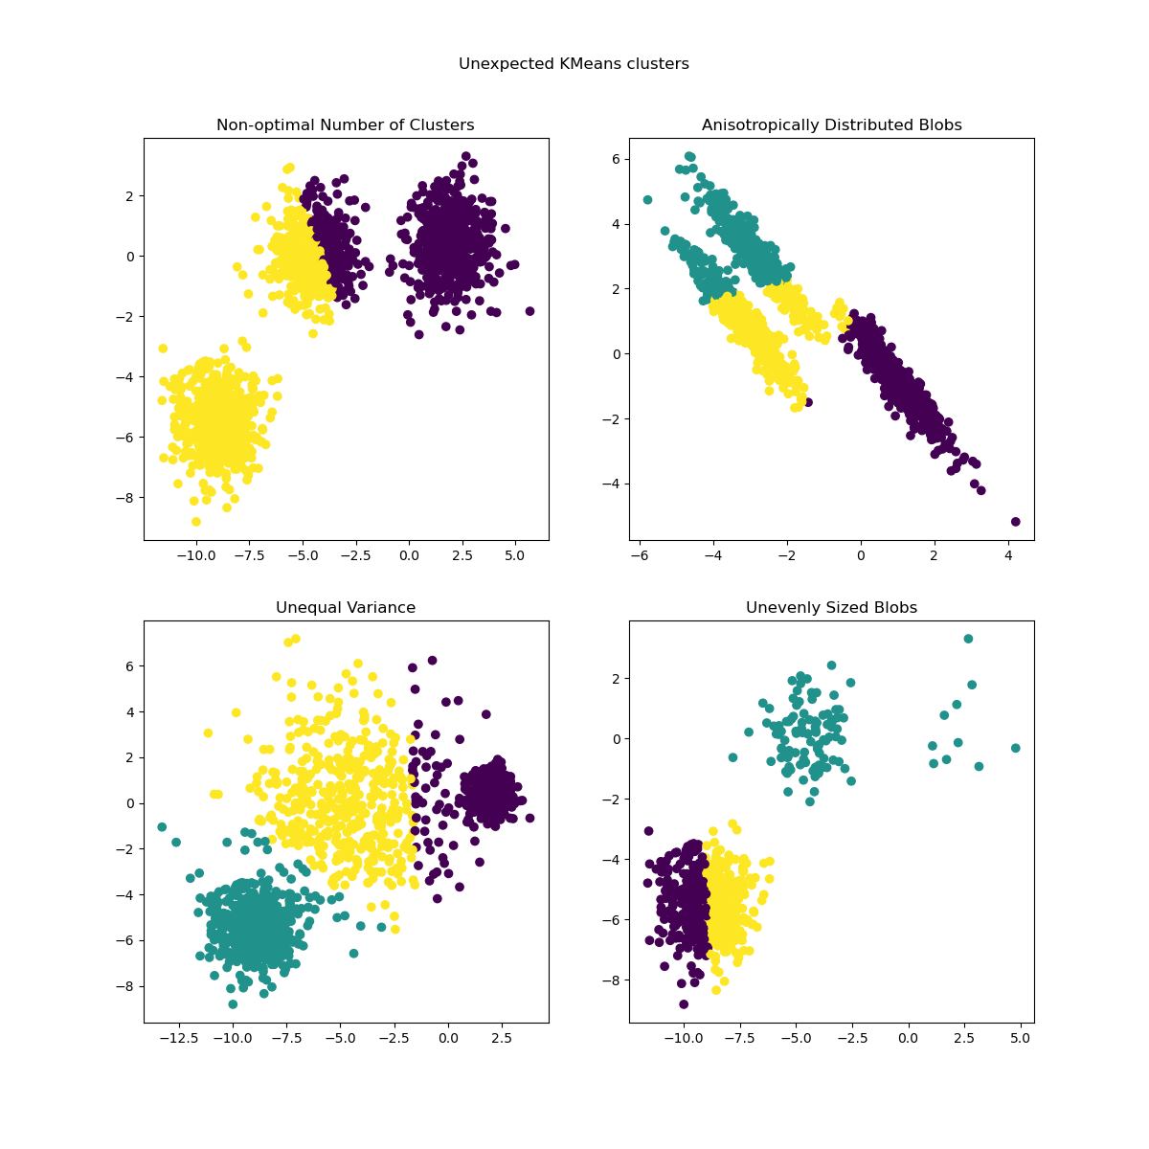](https://scikit-learn.org/stable/auto_examples/cluster/plot_kmeans_assumptions.html)

For more detailed descriptions of the issues shown above and how to address them, refer to the examples [Demonstration of k-means assumptions](https://scikit-learn.org/stable/auto_examples/cluster/plot_kmeans_assumptions.html#sphx-glr-auto-examples-cluster-plot-kmeans-assumptions-py) and [Selecting the number of clusters with silhouette analysis on KMeans clustering](https://scikit-learn.org/stable/auto_examples/cluster/plot_kmeans_silhouette_analysis.html#sphx-glr-auto-examples-cluster-plot-kmeans-silhouette-analysis-py).

K-means is often referred to as Lloyd’s algorithm. In basic terms, the algorithm has three steps. The first step chooses the initial centroids, with the most basic method being to choose k samples from the dataset X. After initialization, K-means consists of looping between the two other steps. The first step assigns each sample to its nearest centroid. The second step creates new centroids by taking the mean value of all of the samples assigned to each previous centroid. The difference between the old and the new centroids are computed and the algorithm repeats these last two steps until this value is less than a threshold. In other words, it repeats until the centroids do not move significantly.

[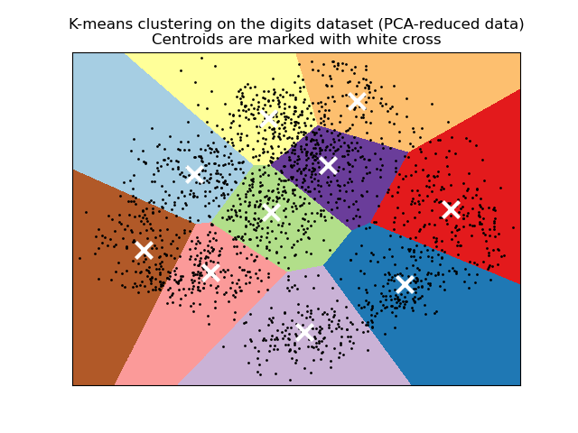](https://scikit-learn.org/stable/auto_examples/cluster/plot_kmeans_digits.html)

K-means is equivalent to the expectation-maximization algorithm with a small, all-equal, diagonal covariance matrix.

The algorithm can also be understood through the concept of [Voronoi diagrams](https://en.wikipedia.org/wiki/Voronoi_diagram). First the Voronoi diagram of the points is calculated using the current centroids. Each segment in the Voronoi diagram becomes a separate cluster. Secondly, the centroids are updated to the mean of each segment. The algorithm then repeats this until a stopping criterion is fulfilled. Usually, the algorithm stops when the relative decrease in the objective function between iterations is less than the given tolerance value. This is not the case in this implementation: iteration stops when centroids move less than the tolerance.

Given enough time, K-means will always converge, however this may be to a local minimum. This is highly dependent on the initialization of the centroids. As a result, the computation is often done several times, with different initializations of the centroids. One method to help address this issue is the k-means++ initialization scheme, which has been implemented in scikit-learn (use the init='k-means++' parameter). This initializes the centroids to be (generally) distant from each other, leading to probably better results than random initialization, as shown in the reference. For detailed examples of comparing different initialization schemes, refer to [A demo of K-Means clustering on the handwritten digits data](https://scikit-learn.org/stable/auto_examples/cluster/plot_kmeans_digits.html#sphx-glr-auto-examples-cluster-plot-kmeans-digits-py) and [Empirical evaluation of the impact of k-means initialization](https://scikit-learn.org/stable/auto_examples/cluster/plot_kmeans_stability_low_dim_dense.html#sphx-glr-auto-examples-cluster-plot-kmeans-stability-low-dim-dense-py).

K-means++ can also be called independently to select seeds for other clustering algorithms, see **[sklearn.cluster.kmeans\_plusplus](https://scikit-learn.org/stable/modules/generated/sklearn.cluster.kmeans_plusplus.html" \l "sklearn.cluster.kmeans_plusplus" \o "sklearn.cluster.kmeans_plusplus)** for details and example usage.

The algorithm supports sample weights, which can be given by a parameter sample\_weight. This allows to assign more weight to some samples when computing cluster centers and values of inertia. For example, assigning a weight of 2 to a sample is equivalent to adding a duplicate of that sample to the dataset X.

**Examples**

* [Clustering text documents using k-means](https://scikit-learn.org/stable/auto_examples/text/plot_document_clustering.html#sphx-glr-auto-examples-text-plot-document-clustering-py): Document clustering using **[KMeans](https://scikit-learn.org/stable/modules/generated/sklearn.cluster.KMeans.html" \l "sklearn.cluster.KMeans" \o "sklearn.cluster.KMeans)** and **[MiniBatchKMeans](https://scikit-learn.org/stable/modules/generated/sklearn.cluster.MiniBatchKMeans.html" \l "sklearn.cluster.MiniBatchKMeans" \o "sklearn.cluster.MiniBatchKMeans)** based on sparse data
* [An example of K-Means++ initialization](https://scikit-learn.org/stable/auto_examples/cluster/plot_kmeans_plusplus.html#sphx-glr-auto-examples-cluster-plot-kmeans-plusplus-py): Using K-means++ to select seeds for other clustering algorithms.

**2.3.2.1. Low-level parallelism**

[**KMeans**](https://scikit-learn.org/stable/modules/generated/sklearn.cluster.KMeans.html#sklearn.cluster.KMeans) benefits from OpenMP based parallelism through Cython. Small chunks of data (256 samples) are processed in parallel, which in addition yields a low memory footprint. For more details on how to control the number of threads, please refer to our [Parallelism](https://scikit-learn.org/stable/computing/parallelism.html#parallelism) notes.

**Examples**

* [Demonstration of k-means assumptions](https://scikit-learn.org/stable/auto_examples/cluster/plot_kmeans_assumptions.html#sphx-glr-auto-examples-cluster-plot-kmeans-assumptions-py): Demonstrating when k-means performs intuitively and when it does not
* [A demo of K-Means clustering on the handwritten digits data](https://scikit-learn.org/stable/auto_examples/cluster/plot_kmeans_digits.html#sphx-glr-auto-examples-cluster-plot-kmeans-digits-py): Clustering handwritten digits

References

**2.3.2.2. Mini Batch K-Means**

The **[MiniBatchKMeans](https://scikit-learn.org/stable/modules/generated/sklearn.cluster.MiniBatchKMeans.html" \l "sklearn.cluster.MiniBatchKMeans" \o "sklearn.cluster.MiniBatchKMeans)** is a variant of the **[KMeans](https://scikit-learn.org/stable/modules/generated/sklearn.cluster.KMeans.html" \l "sklearn.cluster.KMeans" \o "sklearn.cluster.KMeans)** algorithm which uses mini-batches to reduce the computation time, while still attempting to optimise the same objective function. Mini-batches are subsets of the input data, randomly sampled in each training iteration. These mini-batches drastically reduce the amount of computation required to converge to a local solution. In contrast to other algorithms that reduce the convergence time of k-means, mini-batch k-means produces results that are generally only slightly worse than the standard algorithm.

The algorithm iterates between two major steps, similar to vanilla k-means. In the first step, b samples are drawn randomly from the dataset, to form a mini-batch. These are then assigned to the nearest centroid. In the second step, the centroids are updated. In contrast to k-means, this is done on a per-sample basis. For each sample in the mini-batch, the assigned centroid is updated by taking the streaming average of the sample and all previous samples assigned to that centroid. This has the effect of decreasing the rate of change for a centroid over time. These steps are performed until convergence or a predetermined number of iterations is reached.

[**MiniBatchKMeans**](https://scikit-learn.org/stable/modules/generated/sklearn.cluster.MiniBatchKMeans.html#sklearn.cluster.MiniBatchKMeans) converges faster than **[KMeans](https://scikit-learn.org/stable/modules/generated/sklearn.cluster.KMeans.html" \l "sklearn.cluster.KMeans" \o "sklearn.cluster.KMeans)**, but the quality of the results is reduced. In practice this difference in quality can be quite small, as shown in the example and cited reference.

[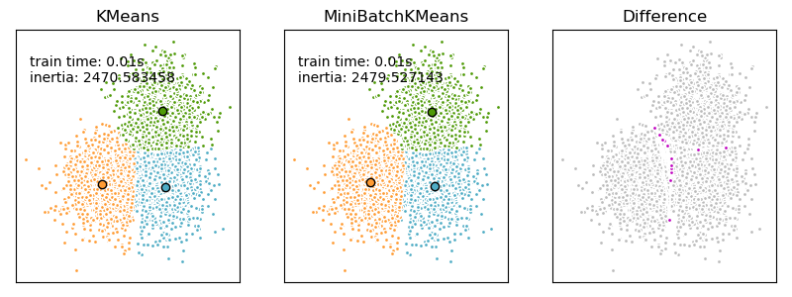](https://scikit-learn.org/stable/auto_examples/cluster/plot_mini_batch_kmeans.html)

**Examples**

* [Comparison of the K-Means and MiniBatchKMeans clustering algorithms](https://scikit-learn.org/stable/auto_examples/cluster/plot_mini_batch_kmeans.html#sphx-glr-auto-examples-cluster-plot-mini-batch-kmeans-py): Comparison of **[KMeans](https://scikit-learn.org/stable/modules/generated/sklearn.cluster.KMeans.html" \l "sklearn.cluster.KMeans" \o "sklearn.cluster.KMeans)** and **[MiniBatchKMeans](https://scikit-learn.org/stable/modules/generated/sklearn.cluster.MiniBatchKMeans.html" \l "sklearn.cluster.MiniBatchKMeans" \o "sklearn.cluster.MiniBatchKMeans)**
* [Clustering text documents using k-means](https://scikit-learn.org/stable/auto_examples/text/plot_document_clustering.html#sphx-glr-auto-examples-text-plot-document-clustering-py): Document clustering using **[KMeans](https://scikit-learn.org/stable/modules/generated/sklearn.cluster.KMeans.html" \l "sklearn.cluster.KMeans" \o "sklearn.cluster.KMeans)** and **[MiniBatchKMeans](https://scikit-learn.org/stable/modules/generated/sklearn.cluster.MiniBatchKMeans.html" \l "sklearn.cluster.MiniBatchKMeans" \o "sklearn.cluster.MiniBatchKMeans)** based on sparse data
* [Online learning of a dictionary of parts of faces](https://scikit-learn.org/stable/auto_examples/cluster/plot_dict_face_patches.html#sphx-glr-auto-examples-cluster-plot-dict-face-patches-py)

References

2.3.3. Affinity Propagation

[**AffinityPropagation**](https://scikit-learn.org/stable/modules/generated/sklearn.cluster.AffinityPropagation.html#sklearn.cluster.AffinityPropagation) creates clusters by sending messages between pairs of samples until convergence. A dataset is then described using a small number of exemplars, which are identified as those most representative of other samples. The messages sent between pairs represent the suitability for one sample to be the exemplar of the other, which is updated in response to the values from other pairs. This updating happens iteratively until convergence, at which point the final exemplars are chosen, and hence the final clustering is given.

[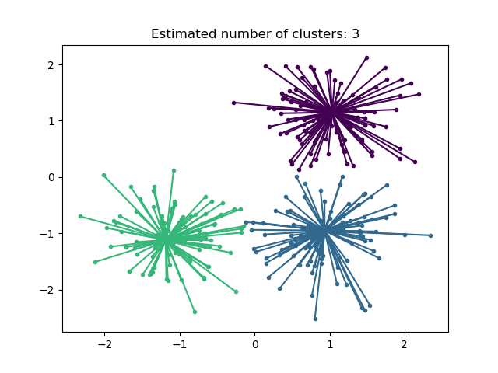](https://scikit-learn.org/stable/auto_examples/cluster/plot_affinity_propagation.html)

Affinity Propagation can be interesting as it chooses the number of clusters based on the data provided. For this purpose, the two important parameters are the *preference*, which controls how many exemplars are used, and the *damping factor* which damps the responsibility and availability messages to avoid numerical oscillations when updating these messages.

The main drawback of Affinity Propagation is its complexity. The algorithm has a time complexity of the order O(N2T), where N is the number of samples and T is the number of iterations until convergence. Further, the memory complexity is of the order O(N2) if a dense similarity matrix is used, but reducible if a sparse similarity matrix is used. This makes Affinity Propagation most appropriate for small to medium sized datasets.

Algorithm description

**Examples**

* [Demo of affinity propagation clustering algorithm](https://scikit-learn.org/stable/auto_examples/cluster/plot_affinity_propagation.html#sphx-glr-auto-examples-cluster-plot-affinity-propagation-py): Affinity Propagation on a synthetic 2D datasets with 3 classes
* [Visualizing the stock market structure](https://scikit-learn.org/stable/auto_examples/applications/plot_stock_market.html#sphx-glr-auto-examples-applications-plot-stock-market-py) Affinity Propagation on financial time series to find groups of companies

2.3.4. Mean Shift

[**MeanShift**](https://scikit-learn.org/stable/modules/generated/sklearn.cluster.MeanShift.html#sklearn.cluster.MeanShift) clustering aims to discover *blobs* in a smooth density of samples. It is a centroid based algorithm, which works by updating candidates for centroids to be the mean of the points within a given region. These candidates are then filtered in a post-processing stage to eliminate near-duplicates to form the final set of centroids.

Mathematical details

The algorithm automatically sets the number of clusters, instead of relying on a parameter bandwidth, which dictates the size of the region to search through. This parameter can be set manually, but can be estimated using the provided estimate\_bandwidth function, which is called if the bandwidth is not set.

The algorithm is not highly scalable, as it requires multiple nearest neighbor searches during the execution of the algorithm. The algorithm is guaranteed to converge, however the algorithm will stop iterating when the change in centroids is small.

Labelling a new sample is performed by finding the nearest centroid for a given sample.

[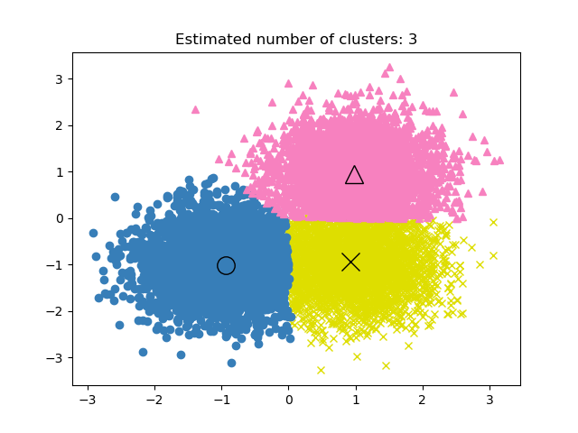](https://scikit-learn.org/stable/auto_examples/cluster/plot_mean_shift.html)

**Examples**

* [A demo of the mean-shift clustering algorithm](https://scikit-learn.org/stable/auto_examples/cluster/plot_mean_shift.html#sphx-glr-auto-examples-cluster-plot-mean-shift-py): Mean Shift clustering on a synthetic 2D datasets with 3 classes.

References

2.3.5. Spectral clustering

[**SpectralClustering**](https://scikit-learn.org/stable/modules/generated/sklearn.cluster.SpectralClustering.html#sklearn.cluster.SpectralClustering) performs a low-dimension embedding of the affinity matrix between samples, followed by clustering, e.g., by KMeans, of the components of the eigenvectors in the low dimensional space. It is especially computationally efficient if the affinity matrix is sparse and the amg solver is used for the eigenvalue problem (Note, the amg solver requires that the [pyamg](https://github.com/pyamg/pyamg) module is installed.)

The present version of SpectralClustering requires the number of clusters to be specified in advance. It works well for a small number of clusters, but is not advised for many clusters.

For two clusters, SpectralClustering solves a convex relaxation of the [normalized cuts](https://people.eecs.berkeley.edu/~malik/papers/SM-ncut.pdf) problem on the similarity graph: cutting the graph in two so that the weight of the edges cut is small compared to the weights of the edges inside each cluster. This criteria is especially interesting when working on images, where graph vertices are pixels, and weights of the edges of the similarity graph are computed using a function of a gradient of the image.

**[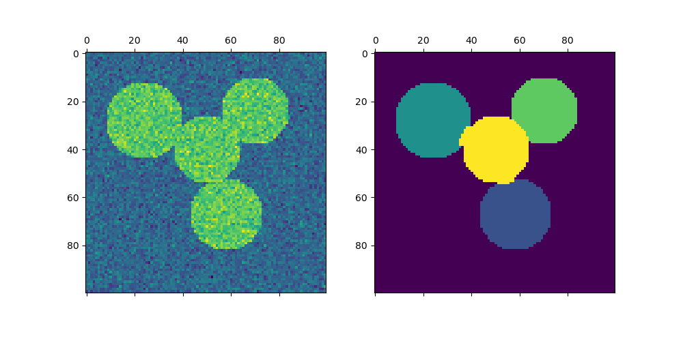](https://scikit-learn.org/stable/auto_examples/cluster/plot_segmentation_toy.html) [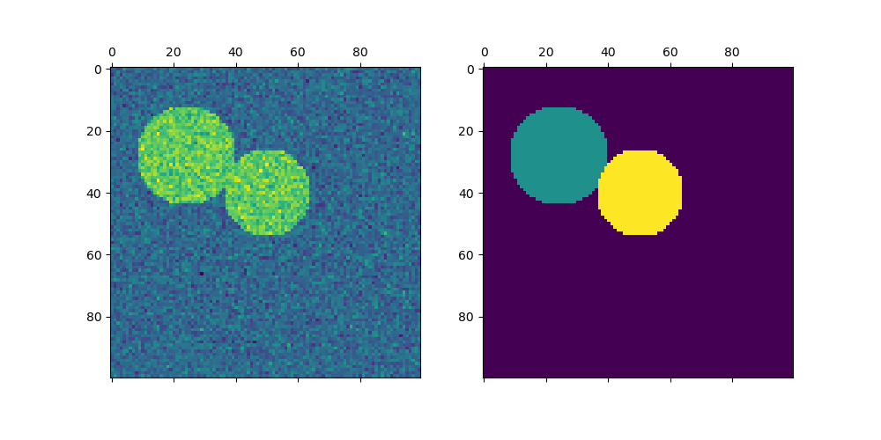](https://scikit-learn.org/stable/auto_examples/cluster/plot_segmentation_toy.html)**

Warning

Transforming distance to well-behaved similarities

Note that if the values of your similarity matrix are not well distributed, e.g. with negative values or with a distance matrix rather than a similarity, the spectral problem will be singular and the problem not solvable. In which case it is advised to apply a transformation to the entries of the matrix. For instance, in the case of a signed distance matrix, is common to apply a heat kernel:

similarity **=** np**.**exp**(-**beta **\*** distance **/** distance**.**std**())**

See the examples for such an application.

**Examples**

* [Spectral clustering for image segmentation](https://scikit-learn.org/stable/auto_examples/cluster/plot_segmentation_toy.html#sphx-glr-auto-examples-cluster-plot-segmentation-toy-py): Segmenting objects from a noisy background using spectral clustering.
* [Segmenting the picture of greek coins in regions](https://scikit-learn.org/stable/auto_examples/cluster/plot_coin_segmentation.html#sphx-glr-auto-examples-cluster-plot-coin-segmentation-py): Spectral clustering to split the image of coins in regions.

**2.3.5.1. Different label assignment strategies**

Different label assignment strategies can be used, corresponding to the assign\_labels parameter of **[SpectralClustering](https://scikit-learn.org/stable/modules/generated/sklearn.cluster.SpectralClustering.html" \l "sklearn.cluster.SpectralClustering" \o "sklearn.cluster.SpectralClustering)**. "kmeans" strategy can match finer details, but can be unstable. In particular, unless you control the random\_state, it may not be reproducible from run-to-run, as it depends on random initialization. The alternative "discretize" strategy is 100% reproducible, but tends to create parcels of fairly even and geometrical shape. The recently added "cluster\_qr" option is a deterministic alternative that tends to create the visually best partitioning on the example application below.

| **assign\_labels="kmeans"** | **assign\_labels="discretize"** | **assign\_labels="cluster\_qr"** |
| --- | --- | --- |
| [coin_kmeans](https://scikit-learn.org/stable/auto_examples/cluster/plot_coin_segmentation.html) | [coin_discretize](https://scikit-learn.org/stable/auto_examples/cluster/plot_coin_segmentation.html) | [coin_cluster_qr](https://scikit-learn.org/stable/auto_examples/cluster/plot_coin_segmentation.html) |

References

**2.3.5.2. Spectral Clustering Graphs**

Spectral Clustering can also be used to partition graphs via their spectral embeddings. In this case, the affinity matrix is the adjacency matrix of the graph, and SpectralClustering is initialized with affinity='precomputed':

>>> **from** sklearn.cluster **import** SpectralClustering

>>> sc **=** SpectralClustering**(3,** affinity**=**'precomputed'**,** n\_init**=100,**

... assign\_labels**=**'discretize'**)**

>>> sc**.**fit\_predict**(**adjacency\_matrix**)**

References

2.3.6. Hierarchical clustering

Hierarchical clustering is a general family of clustering algorithms that build nested clusters by merging or splitting them successively. This hierarchy of clusters is represented as a tree (or dendrogram). The root of the tree is the unique cluster that gathers all the samples, the leaves being the clusters with only one sample. See the [Wikipedia page](https://en.wikipedia.org/wiki/Hierarchical_clustering) for more details.

The **[AgglomerativeClustering](https://scikit-learn.org/stable/modules/generated/sklearn.cluster.AgglomerativeClustering.html" \l "sklearn.cluster.AgglomerativeClustering" \o "sklearn.cluster.AgglomerativeClustering)** object performs a hierarchical clustering using a bottom up approach: each observation starts in its own cluster, and clusters are successively merged together. The linkage criteria determines the metric used for the merge strategy:

* **Ward** minimizes the sum of squared differences within all clusters. It is a variance-minimizing approach and in this sense is similar to the k-means objective function but tackled with an agglomerative hierarchical approach.
* **Maximum** or **complete linkage** minimizes the maximum distance between observations of pairs of clusters.
* **Average linkage** minimizes the average of the distances between all observations of pairs of clusters.
* **Single linkage** minimizes the distance between the closest observations of pairs of clusters.

[**AgglomerativeClustering**](https://scikit-learn.org/stable/modules/generated/sklearn.cluster.AgglomerativeClustering.html#sklearn.cluster.AgglomerativeClustering) can also scale to large number of samples when it is used jointly with a connectivity matrix, but is computationally expensive when no connectivity constraints are added between samples: it considers at each step all the possible merges.

[**FeatureAgglomeration**](https://scikit-learn.org/stable/modules/generated/sklearn.cluster.FeatureAgglomeration.html#sklearn.cluster.FeatureAgglomeration)

The **[FeatureAgglomeration](https://scikit-learn.org/stable/modules/generated/sklearn.cluster.FeatureAgglomeration.html" \l "sklearn.cluster.FeatureAgglomeration" \o "sklearn.cluster.FeatureAgglomeration)** uses agglomerative clustering to group together features that look very similar, thus decreasing the number of features. It is a dimensionality reduction tool, see [Unsupervised dimensionality reduction](https://scikit-learn.org/stable/modules/unsupervised_reduction.html#data-reduction).

**2.3.6.1. Different linkage type: Ward, complete, average, and single linkage**

[**AgglomerativeClustering**](https://scikit-learn.org/stable/modules/generated/sklearn.cluster.AgglomerativeClustering.html#sklearn.cluster.AgglomerativeClustering) supports Ward, single, average, and complete linkage strategies.

[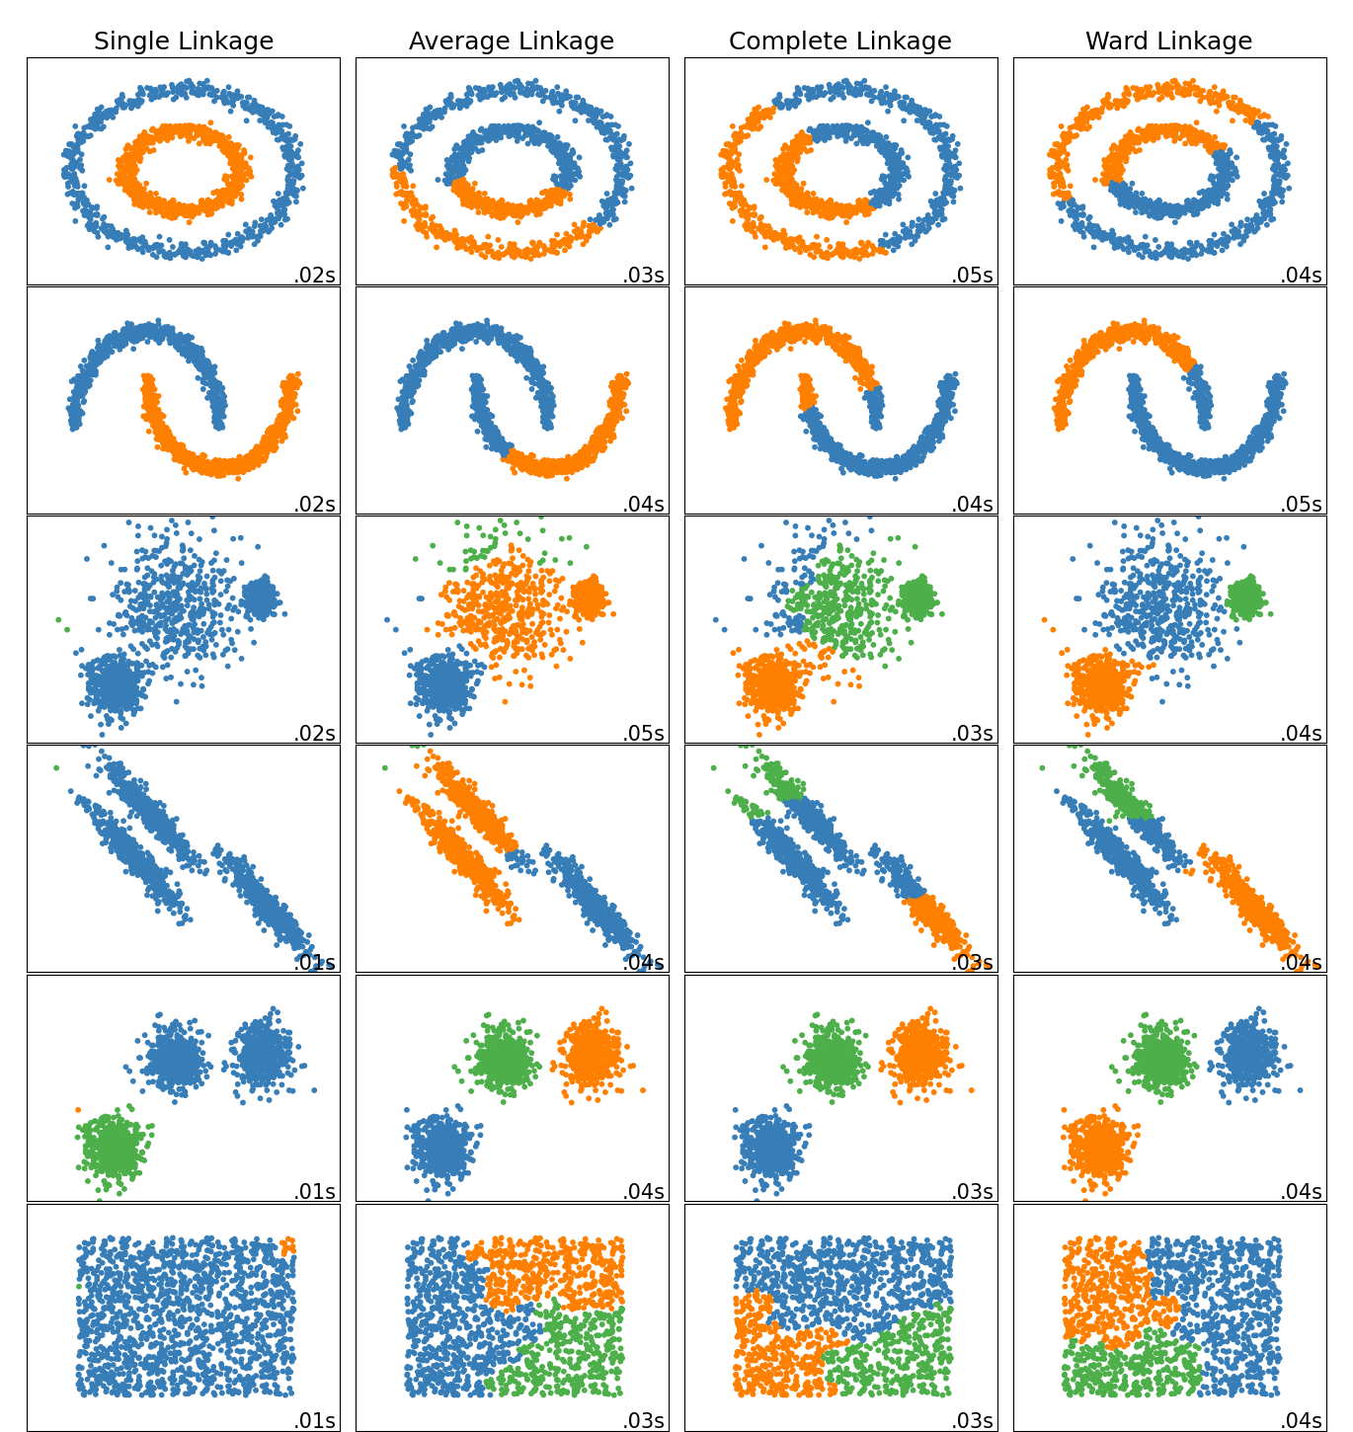](https://scikit-learn.org/stable/auto_examples/cluster/plot_linkage_comparison.html)

Agglomerative cluster has a “rich get richer” behavior that leads to uneven cluster sizes. In this regard, single linkage is the worst strategy, and Ward gives the most regular sizes. However, the affinity (or distance used in clustering) cannot be varied with Ward, thus for non Euclidean metrics, average linkage is a good alternative. Single linkage, while not robust to noisy data, can be computed very efficiently and can therefore be useful to provide hierarchical clustering of larger datasets. Single linkage can also perform well on non-globular data.

**Examples**

* [Various Agglomerative Clustering on a 2D embedding of digits](https://scikit-learn.org/stable/auto_examples/cluster/plot_digits_linkage.html#sphx-glr-auto-examples-cluster-plot-digits-linkage-py): exploration of the different linkage strategies in a real dataset.
  + [Comparing different hierarchical linkage methods on toy datasets](https://scikit-learn.org/stable/auto_examples/cluster/plot_linkage_comparison.html#sphx-glr-auto-examples-cluster-plot-linkage-comparison-py): exploration of the different linkage strategies in toy datasets.

**2.3.6.2. Visualization of cluster hierarchy**

It’s possible to visualize the tree representing the hierarchical merging of clusters as a dendrogram. Visual inspection can often be useful for understanding the structure of the data, though more so in the case of small sample sizes.

[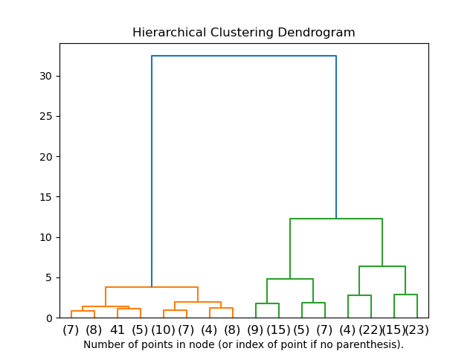](https://scikit-learn.org/stable/auto_examples/cluster/plot_agglomerative_dendrogram.html)

**Examples**

* [Plot Hierarchical Clustering Dendrogram](https://scikit-learn.org/stable/auto_examples/cluster/plot_agglomerative_dendrogram.html#sphx-glr-auto-examples-cluster-plot-agglomerative-dendrogram-py)

**2.3.6.3. Adding connectivity constraints**

An interesting aspect of **[AgglomerativeClustering](https://scikit-learn.org/stable/modules/generated/sklearn.cluster.AgglomerativeClustering.html" \l "sklearn.cluster.AgglomerativeClustering" \o "sklearn.cluster.AgglomerativeClustering)** is that connectivity constraints can be added to this algorithm (only adjacent clusters can be merged together), through a connectivity matrix that defines for each sample the neighboring samples following a given structure of the data. For instance, in the swiss-roll example below, the connectivity constraints forbid the merging of points that are not adjacent on the swiss roll, and thus avoid forming clusters that extend across overlapping folds of the roll.

**[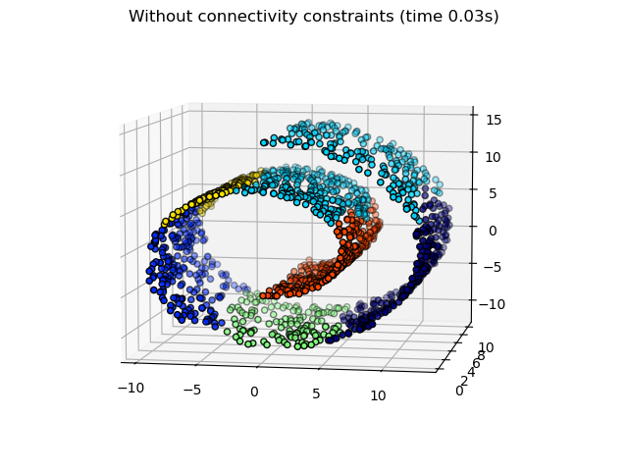](https://scikit-learn.org/stable/auto_examples/cluster/plot_ward_structured_vs_unstructured.html) [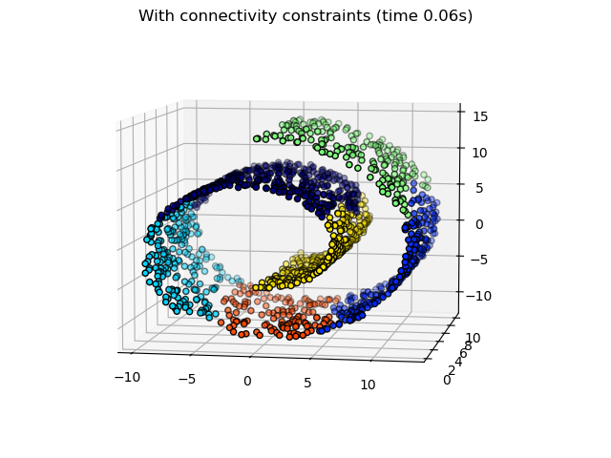](https://scikit-learn.org/stable/auto_examples/cluster/plot_ward_structured_vs_unstructured.html)**

These constraint are useful to impose a certain local structure, but they also make the algorithm faster, especially when the number of the samples is high.

The connectivity constraints are imposed via an connectivity matrix: a scipy sparse matrix that has elements only at the intersection of a row and a column with indices of the dataset that should be connected. This matrix can be constructed from a-priori information: for instance, you may wish to cluster web pages by only merging pages with a link pointing from one to another. It can also be learned from the data, for instance using **[sklearn.neighbors.kneighbors\_graph](https://scikit-learn.org/stable/modules/generated/sklearn.neighbors.kneighbors_graph.html" \l "sklearn.neighbors.kneighbors_graph" \o "sklearn.neighbors.kneighbors_graph)** to restrict merging to nearest neighbors as in [this example](https://scikit-learn.org/stable/auto_examples/cluster/plot_agglomerative_clustering.html#sphx-glr-auto-examples-cluster-plot-agglomerative-clustering-py), or using **[sklearn.feature\_extraction.image.grid\_to\_graph](https://scikit-learn.org/stable/modules/generated/sklearn.feature_extraction.image.grid_to_graph.html" \l "sklearn.feature_extraction.image.grid_to_graph" \o "sklearn.feature_extraction.image.grid_to_graph)** to enable only merging of neighboring pixels on an image, as in the [coin](https://scikit-learn.org/stable/auto_examples/cluster/plot_coin_ward_segmentation.html#sphx-glr-auto-examples-cluster-plot-coin-ward-segmentation-py) example.

Warning

**Connectivity constraints with single, average and complete linkage**

Connectivity constraints and single, complete or average linkage can enhance the ‘rich getting richer’ aspect of agglomerative clustering, particularly so if they are built with **[sklearn.neighbors.kneighbors\_graph](https://scikit-learn.org/stable/modules/generated/sklearn.neighbors.kneighbors_graph.html" \l "sklearn.neighbors.kneighbors_graph" \o "sklearn.neighbors.kneighbors_graph)**. In the limit of a small number of clusters, they tend to give a few macroscopically occupied clusters and almost empty ones. (see the discussion in [Agglomerative clustering with and without structure](https://scikit-learn.org/stable/auto_examples/cluster/plot_agglomerative_clustering.html#sphx-glr-auto-examples-cluster-plot-agglomerative-clustering-py)). Single linkage is the most brittle linkage option with regard to this issue.

[[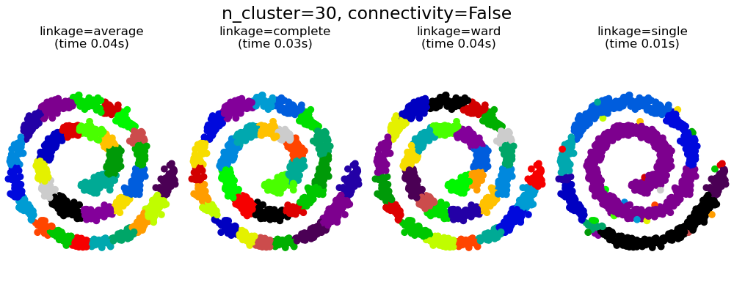](https://scikit-learn.org/stable/auto_examples/cluster/plot_agglomerative_clustering.html) [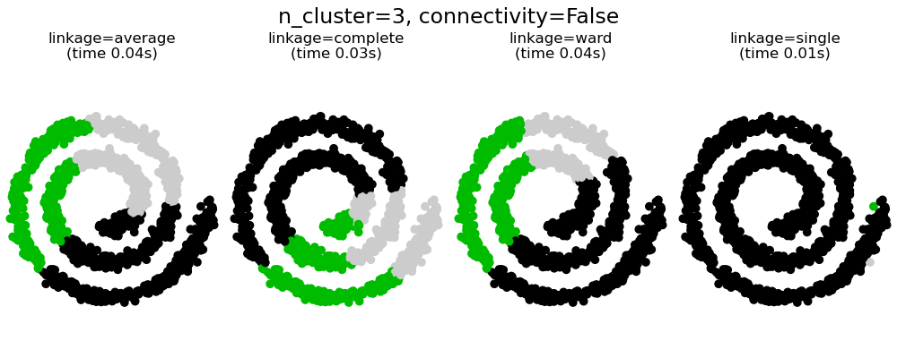](https://scikit-learn.org/stable/auto_examples/cluster/plot_agglomerative_clustering.html) [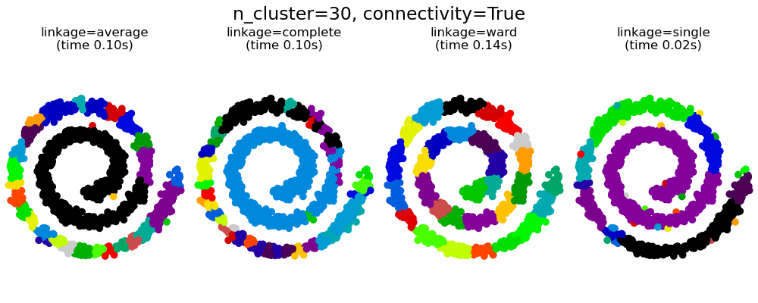](https://scikit-learn.org/stable/auto_examples/cluster/plot_agglomerative_clustering.html) 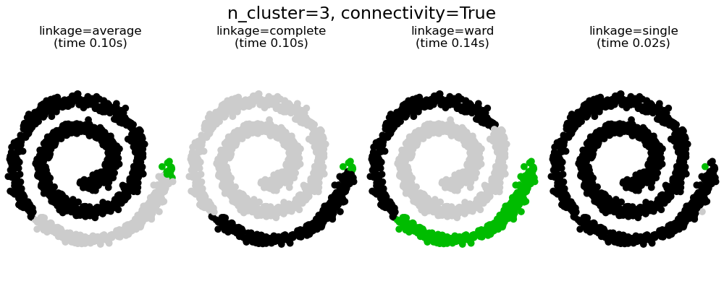](https://scikit-learn.org/stable/auto_examples/cluster/plot_agglomerative_clustering.html)

**Examples**

* [A demo of structured Ward hierarchical clustering on an image of coins](https://scikit-learn.org/stable/auto_examples/cluster/plot_coin_ward_segmentation.html#sphx-glr-auto-examples-cluster-plot-coin-ward-segmentation-py): Ward clustering to split the image of coins in regions.
* [Hierarchical clustering: structured vs unstructured ward](https://scikit-learn.org/stable/auto_examples/cluster/plot_ward_structured_vs_unstructured.html#sphx-glr-auto-examples-cluster-plot-ward-structured-vs-unstructured-py): Example of Ward algorithm on a swiss-roll, comparison of structured approaches versus unstructured approaches.
* [Feature agglomeration vs. univariate selection](https://scikit-learn.org/stable/auto_examples/cluster/plot_feature_agglomeration_vs_univariate_selection.html#sphx-glr-auto-examples-cluster-plot-feature-agglomeration-vs-univariate-selection-py): Example of dimensionality reduction with feature agglomeration based on Ward hierarchical clustering.
* [Agglomerative clustering with and without structure](https://scikit-learn.org/stable/auto_examples/cluster/plot_agglomerative_clustering.html#sphx-glr-auto-examples-cluster-plot-agglomerative-clustering-py)

**2.3.6.4. Varying the metric**

Single, average and complete linkage can be used with a variety of distances (or affinities), in particular Euclidean distance (*l2*), Manhattan distance (or Cityblock, or *l1*), cosine distance, or any precomputed affinity matrix.

* *l1* distance is often good for sparse features, or sparse noise: i.e. many of the features are zero, as in text mining using occurrences of rare words.
* *cosine* distance is interesting because it is invariant to global scalings of the signal.

The guidelines for choosing a metric is to use one that maximizes the distance between samples in different classes, and minimizes that within each class.

[[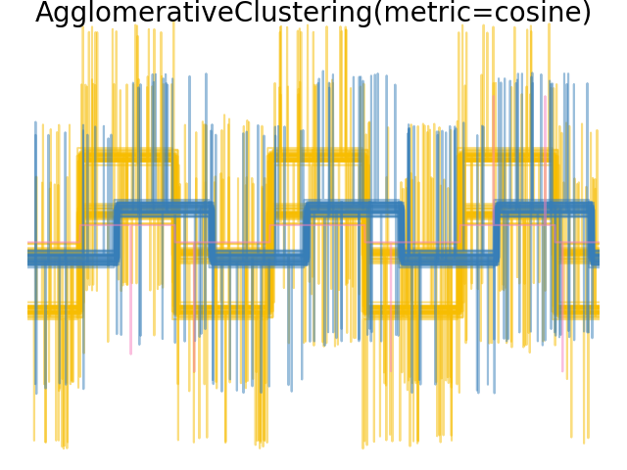](https://scikit-learn.org/stable/auto_examples/cluster/plot_agglomerative_clustering_metrics.html) [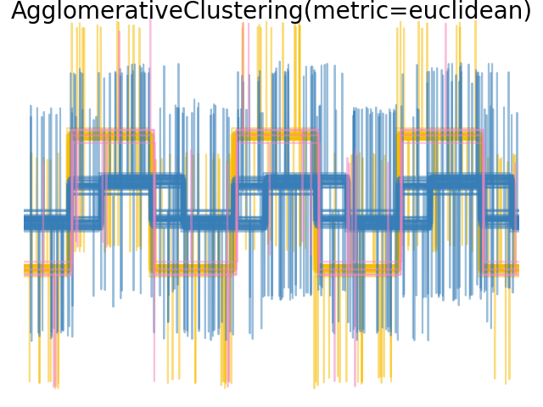](https://scikit-learn.org/stable/auto_examples/cluster/plot_agglomerative_clustering_metrics.html) 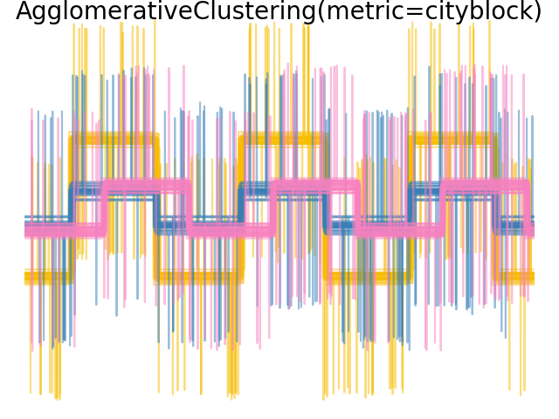](https://scikit-learn.org/stable/auto_examples/cluster/plot_agglomerative_clustering_metrics.html)

**Examples**

* [Agglomerative clustering with different metrics](https://scikit-learn.org/stable/auto_examples/cluster/plot_agglomerative_clustering_metrics.html#sphx-glr-auto-examples-cluster-plot-agglomerative-clustering-metrics-py)

**2.3.6.5. Bisecting K-Means**

The **[BisectingKMeans](https://scikit-learn.org/stable/modules/generated/sklearn.cluster.BisectingKMeans.html" \l "sklearn.cluster.BisectingKMeans" \o "sklearn.cluster.BisectingKMeans)** is an iterative variant of **[KMeans](https://scikit-learn.org/stable/modules/generated/sklearn.cluster.KMeans.html" \l "sklearn.cluster.KMeans" \o "sklearn.cluster.KMeans)**, using divisive hierarchical clustering. Instead of creating all centroids at once, centroids are picked progressively based on a previous clustering: a cluster is split into two new clusters repeatedly until the target number of clusters is reached.

[**BisectingKMeans**](https://scikit-learn.org/stable/modules/generated/sklearn.cluster.BisectingKMeans.html#sklearn.cluster.BisectingKMeans) is more efficient than **[KMeans](https://scikit-learn.org/stable/modules/generated/sklearn.cluster.KMeans.html" \l "sklearn.cluster.KMeans" \o "sklearn.cluster.KMeans)** when the number of clusters is large since it only works on a subset of the data at each bisection while **[KMeans](https://scikit-learn.org/stable/modules/generated/sklearn.cluster.KMeans.html" \l "sklearn.cluster.KMeans" \o "sklearn.cluster.KMeans)** always works on the entire dataset.

Although **[BisectingKMeans](https://scikit-learn.org/stable/modules/generated/sklearn.cluster.BisectingKMeans.html" \l "sklearn.cluster.BisectingKMeans" \o "sklearn.cluster.BisectingKMeans)** can’t benefit from the advantages of the "k-means++" initialization by design, it will still produce comparable results than KMeans(init="k-means++") in terms of inertia at cheaper computational costs, and will likely produce better results than KMeans with a random initialization.

This variant is more efficient to agglomerative clustering if the number of clusters is small compared to the number of data points.

This variant also does not produce empty clusters.

**There exist two strategies for selecting the cluster to split:**

* bisecting\_strategy="largest\_cluster" selects the cluster having the most points
* bisecting\_strategy="biggest\_inertia" selects the cluster with biggest inertia (cluster with biggest Sum of Squared Errors within)

Picking by largest amount of data points in most cases produces result as accurate as picking by inertia and is faster (especially for larger amount of data points, where calculating error may be costly).

Picking by largest amount of data points will also likely produce clusters of similar sizes while KMeans is known to produce clusters of different sizes.

Difference between Bisecting K-Means and regular K-Means can be seen on example [Bisecting K-Means and Regular K-Means Performance Comparison](https://scikit-learn.org/stable/auto_examples/cluster/plot_bisect_kmeans.html#sphx-glr-auto-examples-cluster-plot-bisect-kmeans-py). While the regular K-Means algorithm tends to create non-related clusters, clusters from Bisecting K-Means are well ordered and create quite a visible hierarchy.

References

2.3.7. DBSCAN

The [**DBSCAN**](https://scikit-learn.org/stable/modules/generated/sklearn.cluster.DBSCAN.html#sklearn.cluster.DBSCAN) algorithm views clusters as areas of high density separated by areas of low density. Due to this rather generic view, clusters found by DBSCAN can be any shape, as opposed to k-means which assumes that clusters are convex shaped. The central component to the DBSCAN is the concept of *core samples*, which are samples that are in areas of high density. A cluster is therefore a set of core samples, each close to each other (measured by some distance measure) and a set of non-core samples that are close to a core sample (but are not themselves core samples). There are two parameters to the algorithm, min\_samples and eps, which define formally what we mean when we say *dense*. Higher min\_samples or lower eps indicate higher density necessary to form a cluster.

More formally, we define a core sample as being a sample in the dataset such that there exist min\_samples other samples within a distance of eps, which are defined as *neighbors* of the core sample. This tells us that the core sample is in a dense area of the vector space. A cluster is a set of core samples that can be built by recursively taking a core sample, finding all of its neighbors that are core samples, finding all of *their* neighbors that are core samples, and so on. A cluster also has a set of non-core samples, which are samples that are neighbors of a core sample in the cluster but are not themselves core samples. Intuitively, these samples are on the fringes of a cluster.

Any core sample is part of a cluster, by definition. Any sample that is not a core sample, and is at least eps in distance from any core sample, is considered an outlier by the algorithm.

While the parameter min\_samples primarily controls how tolerant the algorithm is towards noise (on noisy and large data sets it may be desirable to increase this parameter), the parameter eps is *crucial to choose appropriately* for the data set and distance function and usually cannot be left at the default value. It controls the local neighborhood of the points. When chosen too small, most data will not be clustered at all (and labeled as -1 for “noise”). When chosen too large, it causes close clusters to be merged into one cluster, and eventually the entire data set to be returned as a single cluster. Some heuristics for choosing this parameter have been discussed in the literature, for example based on a knee in the nearest neighbor distances plot (as discussed in the references below).

In the figure below, the color indicates cluster membership, with large circles indicating core samples found by the algorithm. Smaller circles are non-core samples that are still part of a cluster. Moreover, the outliers are indicated by black points below.

**[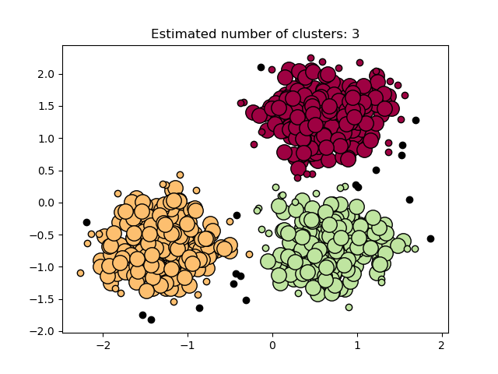](https://scikit-learn.org/stable/auto_examples/cluster/plot_dbscan.html)**

**Examples**

* [Demo of DBSCAN clustering algorithm](https://scikit-learn.org/stable/auto_examples/cluster/plot_dbscan.html#sphx-glr-auto-examples-cluster-plot-dbscan-py)

Implementation

Memory consumption for large sample sizes

References

* [A Density-Based Algorithm for Discovering Clusters in Large Spatial Databases with Noise](https://www.aaai.org/Papers/KDD/1996/KDD96-037.pdf) Ester, M., H. P. Kriegel, J. Sander, and X. Xu, In Proceedings of the 2nd International Conference on Knowledge Discovery and Data Mining, Portland, OR, AAAI Press, pp. 226-231. 1996
* [DBSCAN revisited, revisited: why and how you should (still) use DBSCAN.](https://doi.org/10.1145/3068335) Schubert, E., Sander, J., Ester, M., Kriegel, H. P., & Xu, X. (2017). In ACM Transactions on Database Systems (TODS), 42(3), 19.

2.3.8. HDBSCAN

The [**HDBSCAN**](https://scikit-learn.org/stable/modules/generated/sklearn.cluster.HDBSCAN.html#sklearn.cluster.HDBSCAN) algorithm can be seen as an extension of [**DBSCAN**](https://scikit-learn.org/stable/modules/generated/sklearn.cluster.DBSCAN.html#sklearn.cluster.DBSCAN) and [**OPTICS**](https://scikit-learn.org/stable/modules/generated/sklearn.cluster.OPTICS.html#sklearn.cluster.OPTICS). Specifically, [**DBSCAN**](https://scikit-learn.org/stable/modules/generated/sklearn.cluster.DBSCAN.html#sklearn.cluster.DBSCAN) assumes that the clustering criterion (i.e. density requirement) is *globally homogeneous*. In other words, [**DBSCAN**](https://scikit-learn.org/stable/modules/generated/sklearn.cluster.DBSCAN.html#sklearn.cluster.DBSCAN) may struggle to successfully capture clusters with different densities. [**HDBSCAN**](https://scikit-learn.org/stable/modules/generated/sklearn.cluster.HDBSCAN.html#sklearn.cluster.HDBSCAN) alleviates this assumption and explores all possible density scales by building an alternative representation of the clustering problem.

Note

This implementation is adapted from the original implementation of HDBSCAN, [scikit-learn-contrib/hdbscan](https://github.com/scikit-learn-contrib/hdbscan) based on [[LJ2017]](https://scikit-learn.org/stable/modules/clustering.html#lj2017).

**Examples**

* [Demo of HDBSCAN clustering algorithm](https://scikit-learn.org/stable/auto_examples/cluster/plot_hdbscan.html#sphx-glr-auto-examples-cluster-plot-hdbscan-py)

**2.3.8.1. Mutual Reachability Graph**

HDBSCAN first defines dc(xp), the *core distance* of a sample xp, as the distance to its min\_samples th-nearest neighbor, counting itself. For example, if min\_samples=5 and x∗ is the 5th-nearest neighbor of xp then the core distance is:

dc(xp)=d(xp,x∗).

Next it defines dm(xp,xq), the *mutual reachability distance* of two points xp,xq, as:

dm(xp,xq)=max{dc(xp),dc(xq),d(xp,xq)}

These two notions allow us to construct the *mutual reachability graph* Gms defined for a fixed choice of min\_samples by associating each sample xp with a vertex of the graph, and thus edges between points xp,xq are the mutual reachability distance dm(xp,xq) between them. We may build subsets of this graph, denoted as Gms,ε, by removing any edges with value greater than ε: from the original graph. Any points whose core distance is less than ε: are at this staged marked as noise. The remaining points are then clustered by finding the connected components of this trimmed graph.

Note

Taking the connected components of a trimmed graph Gms,ε is equivalent to running DBSCAN\* with min\_samples and ε. DBSCAN\* is a slightly modified version of DBSCAN mentioned in [[CM2013]](https://scikit-learn.org/stable/modules/clustering.html#cm2013).

**2.3.8.2. Hierarchical Clustering**

HDBSCAN can be seen as an algorithm which performs DBSCAN\* clustering across all values of ε. As mentioned prior, this is equivalent to finding the connected components of the mutual reachability graphs for all values of ε. To do this efficiently, HDBSCAN first extracts a minimum spanning tree (MST) from the fully -connected mutual reachability graph, then greedily cuts the edges with highest weight. An outline of the HDBSCAN algorithm is as follows:

1. Extract the MST of Gms.
2. Extend the MST by adding a “self edge” for each vertex, with weight equal to the core distance of the underlying sample.
3. Initialize a single cluster and label for the MST.
4. Remove the edge with the greatest weight from the MST (ties are removed simultaneously).
5. Assign cluster labels to the connected components which contain the end points of the now-removed edge. If the component does not have at least one edge it is instead assigned a “null” label marking it as noise.
6. Repeat 4-5 until there are no more connected components.

HDBSCAN is therefore able to obtain all possible partitions achievable by DBSCAN\* for a fixed choice of min\_samples in a hierarchical fashion. Indeed, this allows HDBSCAN to perform clustering across multiple densities and as such it no longer needs ε to be given as a hyperparameter. Instead it relies solely on the choice of min\_samples, which tends to be a more robust hyperparameter.

**[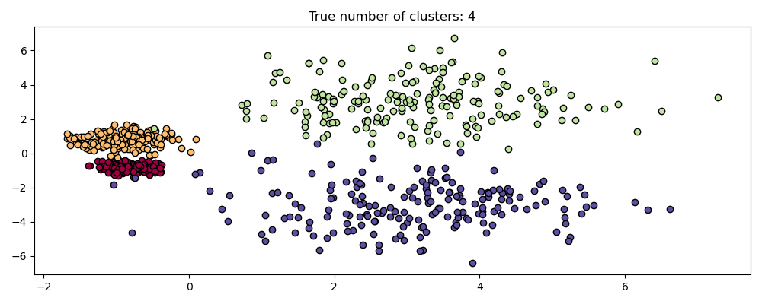](https://scikit-learn.org/stable/auto_examples/cluster/plot_hdbscan.html)**

**[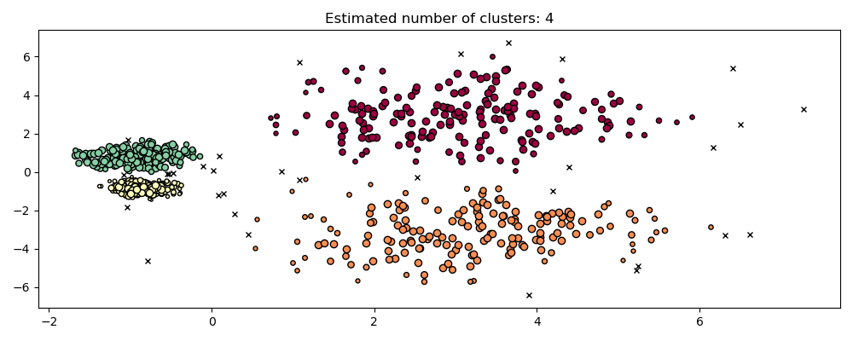](https://scikit-learn.org/stable/auto_examples/cluster/plot_hdbscan.html)**

HDBSCAN can be smoothed with an additional hyperparameter min\_cluster\_size which specifies that during the hierarchical clustering, components with fewer than minimum\_cluster\_size many samples are considered noise. In practice, one can set minimum\_cluster\_size = min\_samples to couple the parameters and simplify the hyperparameter space.

**References**

[[CM2013](https://scikit-learn.org/stable/modules/clustering.html#id10)]

Campello, R.J.G.B., Moulavi, D., Sander, J. (2013). Density-Based Clustering Based on Hierarchical Density Estimates. In: Pei, J., Tseng, V.S., Cao, L., Motoda, H., Xu, G. (eds) Advances in Knowledge Discovery and Data Mining. PAKDD 2013. Lecture Notes in Computer Science(), vol 7819. Springer, Berlin, Heidelberg. [Density-Based Clustering Based on Hierarchical Density Estimates](https://doi.org/10.1007/978-3-642-37456-2_14)

[[LJ2017](https://scikit-learn.org/stable/modules/clustering.html#id9)]

L. McInnes and J. Healy, (2017). Accelerated Hierarchical Density Based Clustering. In: IEEE International Conference on Data Mining Workshops (ICDMW), 2017, pp. 33-42. [Accelerated Hierarchical Density Based Clustering](https://doi.org/10.1109/ICDMW.2017.12)

2.3.9. OPTICS

The [**OPTICS**](https://scikit-learn.org/stable/modules/generated/sklearn.cluster.OPTICS.html#sklearn.cluster.OPTICS) algorithm shares many similarities with the [**DBSCAN**](https://scikit-learn.org/stable/modules/generated/sklearn.cluster.DBSCAN.html#sklearn.cluster.DBSCAN) algorithm, and can be considered a generalization of DBSCAN that relaxes the eps requirement from a single value to a value range. The key difference between DBSCAN and OPTICS is that the OPTICS algorithm builds a *reachability* graph, which assigns each sample both a reachability\_ distance, and a spot within the cluster ordering\_ attribute; these two attributes are assigned when the model is fitted, and are used to determine cluster membership. If OPTICS is run with the default value of *inf* set for max\_eps, then DBSCAN style cluster extraction can be performed repeatedly in linear time for any given eps value using the cluster\_optics\_dbscan method. Setting max\_eps to a lower value will result in shorter run times, and can be thought of as the maximum neighborhood radius from each point to find other potential reachable points.

**[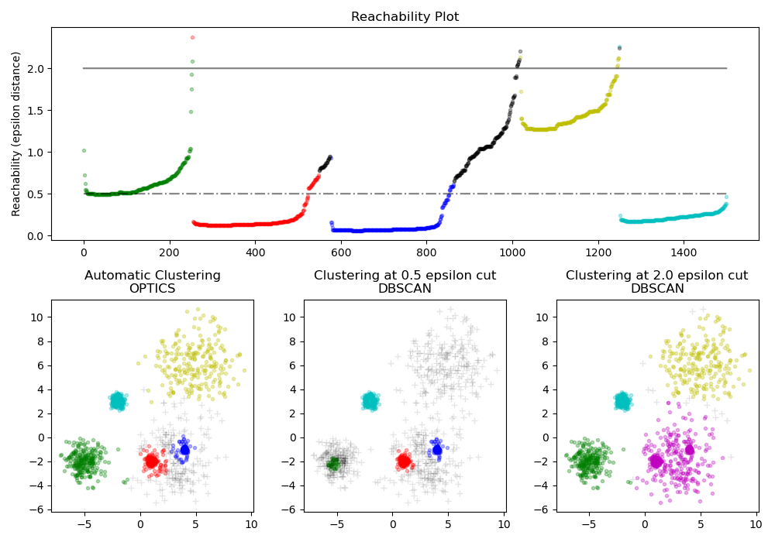](https://scikit-learn.org/stable/auto_examples/cluster/plot_optics.html)**

The *reachability* distances generated by OPTICS allow for variable density extraction of clusters within a single data set. As shown in the above plot, combining *reachability* distances and data set ordering\_ produces a *reachability plot*, where point density is represented on the Y-axis, and points are ordered such that nearby points are adjacent. ‘Cutting’ the reachability plot at a single value produces DBSCAN like results; all points above the ‘cut’ are classified as noise, and each time that there is a break when reading from left to right signifies a new cluster. The default cluster extraction with OPTICS looks at the steep slopes within the graph to find clusters, and the user can define what counts as a steep slope using the parameter xi. There are also other possibilities for analysis on the graph itself, such as generating hierarchical representations of the data through reachability-plot dendrograms, and the hierarchy of clusters detected by the algorithm can be accessed through the cluster\_hierarchy\_ parameter. The plot above has been color-coded so that cluster colors in planar space match the linear segment clusters of the reachability plot. Note that the blue and red clusters are adjacent in the reachability plot, and can be hierarchically represented as children of a larger parent cluster.

**Examples**

* [Demo of OPTICS clustering algorithm](https://scikit-learn.org/stable/auto_examples/cluster/plot_optics.html#sphx-glr-auto-examples-cluster-plot-optics-py)

Comparison with DBSCAN

Computational Complexity

References

2.3.10. BIRCH

The [**Birch**](https://scikit-learn.org/stable/modules/generated/sklearn.cluster.Birch.html#sklearn.cluster.Birch) builds a tree called the Clustering Feature Tree (CFT) for the given data. The data is essentially lossy compressed to a set of Clustering Feature nodes (CF Nodes). The CF Nodes have a number of subclusters called Clustering Feature subclusters (CF Subclusters) and these CF Subclusters located in the non-terminal CF Nodes can have CF Nodes as children.

The CF Subclusters hold the necessary information for clustering which prevents the need to hold the entire input data in memory. This information includes:

* Number of samples in a subcluster.
* Linear Sum - An n-dimensional vector holding the sum of all samples
* Squared Sum - Sum of the squared L2 norm of all samples.
* Centroids - To avoid recalculation linear sum / n\_samples.
* Squared norm of the centroids.

The BIRCH algorithm has two parameters, the threshold and the branching factor. The branching factor limits the number of subclusters in a node and the threshold limits the distance between the entering sample and the existing subclusters.

This algorithm can be viewed as an instance or data reduction method, since it reduces the input data to a set of subclusters which are obtained directly from the leaves of the CFT. This reduced data can be further processed by feeding it into a global clusterer. This global clusterer can be set by n\_clusters. If n\_clusters is set to None, the subclusters from the leaves are directly read off, otherwise a global clustering step labels these subclusters into global clusters (labels) and the samples are mapped to the global label of the nearest subcluster.

Algorithm description

BIRCH or MiniBatchKMeans?

[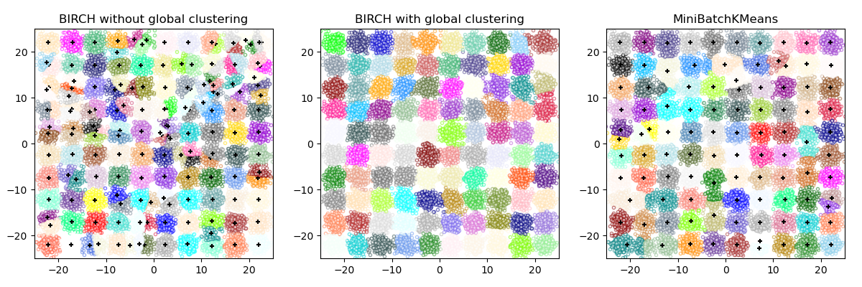](https://scikit-learn.org/stable/auto_examples/cluster/plot_birch_vs_minibatchkmeans.html)

How to use partial\_fit?

References

2.3.11. Clustering performance evaluation

Evaluating the performance of a clustering algorithm is not as trivial as counting the number of errors or the precision and recall of a supervised classification algorithm. In particular any evaluation metric should not take the absolute values of the cluster labels into account but rather if this clustering define separations of the data similar to some ground truth set of classes or satisfying some assumption such that members belong to the same class are more similar than members of different classes according to some similarity metric.

**2.3.11.1. Rand index**

Given the knowledge of the ground truth class assignments labels\_true and our clustering algorithm assignments of the same samples labels\_pred, the **(adjusted or unadjusted) Rand index** is a function that measures the **similarity** of the two assignments, ignoring permutations:

>>> **from** sklearn **import** metrics

>>> labels\_true **=** **[0,** **0,** **0,** **1,** **1,** **1]**

>>> labels\_pred **=** **[0,** **0,** **1,** **1,** **2,** **2]**

>>> metrics**.**rand\_score**(**labels\_true**,** labels\_pred**)**

*0.66*

The Rand index does not ensure to obtain a value close to 0.0 for a random labelling. The adjusted Rand index **corrects for chance** and will give such a baseline.

>>> metrics**.**adjusted\_rand\_score**(**labels\_true**,** labels\_pred**)**

*0.24*

As with all clustering metrics, one can permute 0 and 1 in the predicted labels, rename 2 to 3, and get the same score:

>>> labels\_pred **=** **[1,** **1,** **0,** **0,** **3,** **3]**

>>> metrics**.**rand\_score**(**labels\_true**,** labels\_pred**)**

*0.66*

>>> metrics**.**adjusted\_rand\_score**(**labels\_true**,** labels\_pred**)**

*0.24*

Furthermore, both **[rand\_score](https://scikit-learn.org/stable/modules/generated/sklearn.metrics.rand_score.html" \l "sklearn.metrics.rand_score" \o "sklearn.metrics.rand_score)** and **[adjusted\_rand\_score](https://scikit-learn.org/stable/modules/generated/sklearn.metrics.adjusted_rand_score.html" \l "sklearn.metrics.adjusted_rand_score" \o "sklearn.metrics.adjusted_rand_score)** are **symmetric**: swapping the argument does not change the scores. They can thus be used as **consensus measures**:

>>> metrics**.**rand\_score**(**labels\_pred**,** labels\_true**)**

*0.66*

>>> metrics**.**adjusted\_rand\_score**(**labels\_pred**,** labels\_true**)**

*0.24*

Perfect labeling is scored 1.0:

>>> labels\_pred **=** labels\_true**[:]**

>>> metrics**.**rand\_score**(**labels\_true**,** labels\_pred**)**

*1.0*

>>> metrics**.**adjusted\_rand\_score**(**labels\_true**,** labels\_pred**)**

*1.0*

Poorly agreeing labels (e.g. independent labelings) have lower scores, and for the adjusted Rand index the score will be negative or close to zero. However, for the unadjusted Rand index the score, while lower, will not necessarily be close to zero:

>>> labels\_true **=** **[0,** **0,** **0,** **0,** **0,** **0,** **1,** **1]**

>>> labels\_pred **=** **[0,** **1,** **2,** **3,** **4,** **5,** **5,** **6]**

>>> metrics**.**rand\_score**(**labels\_true**,** labels\_pred**)**

*0.39*

>>> metrics**.**adjusted\_rand\_score**(**labels\_true**,** labels\_pred**)**

*-0.072*

**Advantages:**

* **Interpretability**: The unadjusted Rand index is proportional to the number of sample pairs whose labels are the same in both labels\_pred and labels\_true, or are different in both.
* **Random (uniform) label assignments have an adjusted Rand index score close to 0.0** for any value of n\_clusters and n\_samples (which is not the case for the unadjusted Rand index or the V-measure for instance).
* **Bounded range**: Lower values indicate different labelings, similar clusterings have a high (adjusted or unadjusted) Rand index, 1.0 is the perfect match score. The score range is [0, 1] for the unadjusted Rand index and [-0.5, 1] for the adjusted Rand index.
* **No assumption is made on the cluster structure**: The (adjusted or unadjusted) Rand index can be used to compare all kinds of clustering algorithms, and can be used to compare clustering algorithms such as k-means which assumes isotropic blob shapes with results of spectral clustering algorithms which can find cluster with “folded” shapes.

**Drawbacks:**

* Contrary to inertia, the **(adjusted or unadjusted) Rand index requires knowledge of the ground truth classes** which is almost never available in practice or requires manual assignment by human annotators (as in the supervised learning setting).

However (adjusted or unadjusted) Rand index can also be useful in a purely unsupervised setting as a building block for a Consensus Index that can be used for clustering model selection (TODO).

* The **unadjusted Rand index is often close to 1.0** even if the clusterings themselves differ significantly. This can be understood when interpreting the Rand index as the accuracy of element pair labeling resulting from the clusterings: In practice there often is a majority of element pairs that are assigned the different pair label under both the predicted and the ground truth clustering resulting in a high proportion of pair labels that agree, which leads subsequently to a high score.

**Examples**

* [Adjustment for chance in clustering performance evaluation](https://scikit-learn.org/stable/auto_examples/cluster/plot_adjusted_for_chance_measures.html#sphx-glr-auto-examples-cluster-plot-adjusted-for-chance-measures-py): Analysis of the impact of the dataset size on the value of clustering measures for random assignments.

Mathematical formulation

References

**2.3.11.2. Mutual Information based scores**

Given the knowledge of the ground truth class assignments labels\_true and our clustering algorithm assignments of the same samples labels\_pred, the **Mutual Information** is a function that measures the **agreement** of the two assignments, ignoring permutations. Two different normalized versions of this measure are available, **Normalized Mutual Information (NMI)** and **Adjusted Mutual Information (AMI)**. NMI is often used in the literature, while AMI was proposed more recently and is **normalized against chance**:

>>> **from** sklearn **import** metrics

>>> labels\_true **=** **[0,** **0,** **0,** **1,** **1,** **1]**

>>> labels\_pred **=** **[0,** **0,** **1,** **1,** **2,** **2]**

>>> metrics**.**adjusted\_mutual\_info\_score**(**labels\_true**,** labels\_pred**)**

*0.22504*

One can permute 0 and 1 in the predicted labels, rename 2 to 3 and get the same score:

>>> labels\_pred **=** **[1,** **1,** **0,** **0,** **3,** **3]**

>>> metrics**.**adjusted\_mutual\_info\_score**(**labels\_true**,** labels\_pred**)**

*0.22504*

All, [**mutual\_info\_score**](https://scikit-learn.org/stable/modules/generated/sklearn.metrics.mutual_info_score.html#sklearn.metrics.mutual_info_score), [**adjusted\_mutual\_info\_score**](https://scikit-learn.org/stable/modules/generated/sklearn.metrics.adjusted_mutual_info_score.html#sklearn.metrics.adjusted_mutual_info_score) and [**normalized\_mutual\_info\_score**](https://scikit-learn.org/stable/modules/generated/sklearn.metrics.normalized_mutual_info_score.html#sklearn.metrics.normalized_mutual_info_score) are symmetric: swapping the argument does not change the score. Thus they can be used as a **consensus measure**:

>>> metrics**.**adjusted\_mutual\_info\_score**(**labels\_pred**,** labels\_true**)**

*0.22504*

Perfect labeling is scored 1.0:

>>> labels\_pred **=** labels\_true**[:]**

>>> metrics**.**adjusted\_mutual\_info\_score**(**labels\_true**,** labels\_pred**)**

*1.0*

>>> metrics**.**normalized\_mutual\_info\_score**(**labels\_true**,** labels\_pred**)**

*1.0*

This is not true for mutual\_info\_score, which is therefore harder to judge:

>>> metrics**.**mutual\_info\_score**(**labels\_true**,** labels\_pred**)**

*0.69*

Bad (e.g. independent labelings) have non-positive scores:

>>> labels\_true **=** **[0,** **1,** **2,** **0,** **3,** **4,** **5,** **1]**

>>> labels\_pred **=** **[1,** **1,** **0,** **0,** **2,** **2,** **2,** **2]**

>>> metrics**.**adjusted\_mutual\_info\_score**(**labels\_true**,** labels\_pred**)**

*-0.10526*

**Advantages:**

* **Random (uniform) label assignments have a AMI score close to 0.0** for any value of n\_clusters and n\_samples (which is not the case for raw Mutual Information or the V-measure for instance).
* **Upper bound of 1**: Values close to zero indicate two label assignments that are largely independent, while values close to one indicate significant agreement. Further, an AMI of exactly 1 indicates that the two label assignments are equal (with or without permutation).

**Drawbacks:**

* Contrary to inertia, **MI-based measures require the knowledge of the ground truth classes** while almost never available in practice or requires manual assignment by human annotators (as in the supervised learning setting).

However MI-based measures can also be useful in purely unsupervised setting as a building block for a Consensus Index that can be used for clustering model selection.

* NMI and MI are not adjusted against chance.

**Examples**

* [Adjustment for chance in clustering performance evaluation](https://scikit-learn.org/stable/auto_examples/cluster/plot_adjusted_for_chance_measures.html#sphx-glr-auto-examples-cluster-plot-adjusted-for-chance-measures-py): Analysis of the impact of the dataset size on the value of clustering measures for random assignments. This example also includes the Adjusted Rand Index.

Mathematical formulation

**2.3.11.3. Homogeneity, completeness and V-measure**

Given the knowledge of the ground truth class assignments of the samples, it is possible to define some intuitive metric using conditional entropy analysis.

In particular Rosenberg and Hirschberg (2007) define the following two desirable objectives for any cluster assignment:

* **homogeneity**: each cluster contains only members of a single class.
* **completeness**: all members of a given class are assigned to the same cluster.

We can turn those concept as scores **[homogeneity\_score](https://scikit-learn.org/stable/modules/generated/sklearn.metrics.homogeneity_score.html" \l "sklearn.metrics.homogeneity_score" \o "sklearn.metrics.homogeneity_score)** and **[completeness\_score](https://scikit-learn.org/stable/modules/generated/sklearn.metrics.completeness_score.html" \l "sklearn.metrics.completeness_score" \o "sklearn.metrics.completeness_score)**. Both are bounded below by 0.0 and above by 1.0 (higher is better):

>>> **from** sklearn **import** metrics

>>> labels\_true **=** **[0,** **0,** **0,** **1,** **1,** **1]**

>>> labels\_pred **=** **[0,** **0,** **1,** **1,** **2,** **2]**

>>> metrics**.**homogeneity\_score**(**labels\_true**,** labels\_pred**)**

*0.66*

>>> metrics**.**completeness\_score**(**labels\_true**,** labels\_pred**)**

*0.42*

Their harmonic mean called **V-measure** is computed by **[v\_measure\_score](https://scikit-learn.org/stable/modules/generated/sklearn.metrics.v_measure_score.html" \l "sklearn.metrics.v_measure_score" \o "sklearn.metrics.v_measure_score)**:

>>> metrics**.**v\_measure\_score**(**labels\_true**,** labels\_pred**)**

*0.516*

This function’s formula is as follows:

v=(1+β)×homogeneity×completeness(β×homogeneity+completeness)

beta defaults to a value of 1.0, but for using a value less than 1 for beta:

>>> metrics**.**v\_measure\_score**(**labels\_true**,** labels\_pred**,** beta**=0.6)**

*0.547*

more weight will be attributed to homogeneity, and using a value greater than 1:

>>> metrics**.**v\_measure\_score**(**labels\_true**,** labels\_pred**,** beta**=1.8)**

*0.48*

more weight will be attributed to completeness.

The V-measure is actually equivalent to the mutual information (NMI) discussed above, with the aggregation function being the arithmetic mean [[B2011]](https://scikit-learn.org/stable/modules/clustering.html#b2011).

Homogeneity, completeness and V-measure can be computed at once using **[homogeneity\_completeness\_v\_measure](https://scikit-learn.org/stable/modules/generated/sklearn.metrics.homogeneity_completeness_v_measure.html" \l "sklearn.metrics.homogeneity_completeness_v_measure" \o "sklearn.metrics.homogeneity_completeness_v_measure)** as follows:

>>> metrics**.**homogeneity\_completeness\_v\_measure**(**labels\_true**,** labels\_pred**)**

*(0.67, 0.42, 0.52)*

The following clustering assignment is slightly better, since it is homogeneous but not complete:

>>> labels\_pred **=** **[0,** **0,** **0,** **1,** **2,** **2]**

>>> metrics**.**homogeneity\_completeness\_v\_measure**(**labels\_true**,** labels\_pred**)**

*(1.0, 0.68, 0.81)*

Note

[**v\_measure\_score**](https://scikit-learn.org/stable/modules/generated/sklearn.metrics.v_measure_score.html#sklearn.metrics.v_measure_score) is **symmetric**: it can be used to evaluate the **agreement** of two independent assignments on the same dataset.

This is not the case for **[completeness\_score](https://scikit-learn.org/stable/modules/generated/sklearn.metrics.completeness_score.html" \l "sklearn.metrics.completeness_score" \o "sklearn.metrics.completeness_score)** and **[homogeneity\_score](https://scikit-learn.org/stable/modules/generated/sklearn.metrics.homogeneity_score.html" \l "sklearn.metrics.homogeneity_score" \o "sklearn.metrics.homogeneity_score)**: both are bound by the relationship:

homogeneity\_score**(**a**,** b**)** **==** completeness\_score**(**b**,** a**)**

**Advantages:**

* **Bounded scores**: 0.0 is as bad as it can be, 1.0 is a perfect score.
* Intuitive interpretation: clustering with bad V-measure can be **qualitatively analyzed in terms of homogeneity and completeness** to better feel what ‘kind’ of mistakes is done by the assignment.
* **No assumption is made on the cluster structure**: can be used to compare clustering algorithms such as k-means which assumes isotropic blob shapes with results of spectral clustering algorithms which can find cluster with “folded” shapes.

**Drawbacks:**

* The previously introduced metrics are **not normalized with regards to random labeling**: this means that depending on the number of samples, clusters and ground truth classes, a completely random labeling will not always yield the same values for homogeneity, completeness and hence v-measure. In particular **random labeling won’t yield zero scores especially when the number of clusters is large**.

This problem can safely be ignored when the number of samples is more than a thousand and the number of clusters is less than 10. **For smaller sample sizes or larger number of clusters it is safer to use an adjusted index such as the Adjusted Rand Index (ARI)**.

[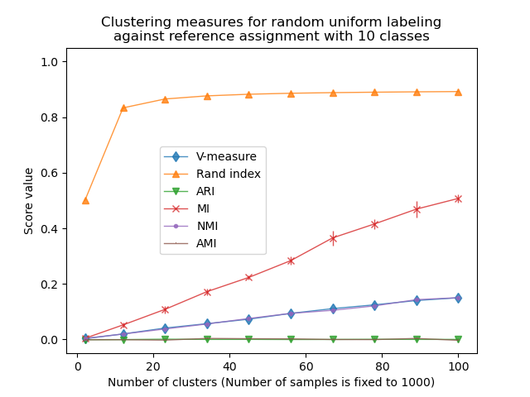](https://scikit-learn.org/stable/auto_examples/cluster/plot_adjusted_for_chance_measures.html)

* These metrics **require the knowledge of the ground truth classes** while almost never available in practice or requires manual assignment by human annotators (as in the supervised learning setting).

**Examples**

* [Adjustment for chance in clustering performance evaluation](https://scikit-learn.org/stable/auto_examples/cluster/plot_adjusted_for_chance_measures.html#sphx-glr-auto-examples-cluster-plot-adjusted-for-chance-measures-py): Analysis of the impact of the dataset size on the value of clustering measures for random assignments.

Mathematical formulation

**References**

* [V-Measure: A conditional entropy-based external cluster evaluation measure](https://aclweb.org/anthology/D/D07/D07-1043.pdf) Andrew Rosenberg and Julia Hirschberg, 2007

[[B2011](https://scikit-learn.org/stable/modules/clustering.html#id17)]

[Identification and Characterization of Events in Social Media](http://www.cs.columbia.edu/~hila/hila-thesis-distributed.pdf), Hila Becker, PhD Thesis.

**2.3.11.4. Fowlkes-Mallows scores**

The original Fowlkes-Mallows index (FMI) was intended to measure the similarity between two clustering results, which is inherently an unsupervised comparison. The supervised adaptation of the Fowlkes-Mallows index (as implemented in **[sklearn.metrics.fowlkes\_mallows\_score](https://scikit-learn.org/stable/modules/generated/sklearn.metrics.fowlkes_mallows_score.html" \l "sklearn.metrics.fowlkes_mallows_score" \o "sklearn.metrics.fowlkes_mallows_score)**) can be used when the ground truth class assignments of the samples are known. The FMI is defined as the geometric mean of the pairwise precision and recall:

FMI=TP(TP+FP)(TP+FN)

In the above formula:

* TP (**True Positive**): The number of pairs of points that are clustered together both in the true labels and in the predicted labels.
* FP (**False Positive**): The number of pairs of points that are clustered together in the predicted labels but not in the true labels.
* FN (**False Negative**): The number of pairs of points that are clustered together in the true labels but not in the predicted labels.

The score ranges from 0 to 1. A high value indicates a good similarity between two clusters.

>>> **from** sklearn **import** metrics

>>> labels\_true **=** **[0,** **0,** **0,** **1,** **1,** **1]**

>>> labels\_pred **=** **[0,** **0,** **1,** **1,** **2,** **2]**

>>> metrics**.**fowlkes\_mallows\_score**(**labels\_true**,** labels\_pred**)**

*0.47140*

One can permute 0 and 1 in the predicted labels, rename 2 to 3 and get the same score:

>>> labels\_pred **=** **[1,** **1,** **0,** **0,** **3,** **3]**

>>> metrics**.**fowlkes\_mallows\_score**(**labels\_true**,** labels\_pred**)**

*0.47140*

Perfect labeling is scored 1.0:

>>> labels\_pred **=** labels\_true**[:]**

>>> metrics**.**fowlkes\_mallows\_score**(**labels\_true**,** labels\_pred**)**

*1.0*

Bad (e.g. independent labelings) have zero scores:

>>> labels\_true **=** **[0,** **1,** **2,** **0,** **3,** **4,** **5,** **1]**

>>> labels\_pred **=** **[1,** **1,** **0,** **0,** **2,** **2,** **2,** **2]**

>>> metrics**.**fowlkes\_mallows\_score**(**labels\_true**,** labels\_pred**)**

*0.0*

**Advantages:**

* **Random (uniform) label assignments have a FMI score close to 0.0** for any value of n\_clusters and n\_samples (which is not the case for raw Mutual Information or the V-measure for instance).
* **Upper-bounded at 1**: Values close to zero indicate two label assignments that are largely independent, while values close to one indicate significant agreement. Further, values of exactly 0 indicate **purely** independent label assignments and a FMI of exactly 1 indicates that the two label assignments are equal (with or without permutation).
* **No assumption is made on the cluster structure**: can be used to compare clustering algorithms such as k-means which assumes isotropic blob shapes with results of spectral clustering algorithms which can find cluster with “folded” shapes.

**Drawbacks:**

* Contrary to inertia, **FMI-based measures require the knowledge of the ground truth classes** while almost never available in practice or requires manual assignment by human annotators (as in the supervised learning setting).

References

**2.3.11.5. Silhouette Coefficient**

If the ground truth labels are not known, evaluation must be performed using the model itself. The Silhouette Coefficient (**[sklearn.metrics.silhouette\_score](https://scikit-learn.org/stable/modules/generated/sklearn.metrics.silhouette_score.html" \l "sklearn.metrics.silhouette_score" \o "sklearn.metrics.silhouette_score)**) is an example of such an evaluation, where a higher Silhouette Coefficient score relates to a model with better defined clusters. The Silhouette Coefficient is defined for each sample and is composed of two scores:

* **a**: The mean distance between a sample and all other points in the same class.
* **b**: The mean distance between a sample and all other points in the *next nearest cluster*.

The Silhouette Coefficient *s* for a single sample is then given as:

s=b−amax(a,b)

The Silhouette Coefficient for a set of samples is given as the mean of the Silhouette Coefficient for each sample.

>>> **from** sklearn **import** metrics

>>> **from** sklearn.metrics **import** pairwise\_distances

>>> **from** sklearn **import** datasets

>>> X**,** y **=** datasets**.**load\_iris**(**return\_X\_y**=True)**

In normal usage, the Silhouette Coefficient is applied to the results of a cluster analysis.

>>> **import** numpy **as** np

>>> **from** sklearn.cluster **import** KMeans

>>> kmeans\_model **=** KMeans**(**n\_clusters**=3,** random\_state**=1).**fit**(**X**)**

>>> labels **=** kmeans\_model**.**labels\_

>>> metrics**.**silhouette\_score**(**X**,** labels**,** metric**=**'euclidean'**)**

*0.55*

**Advantages:**

* The score is bounded between -1 for incorrect clustering and +1 for highly dense clustering. Scores around zero indicate overlapping clusters.
* The score is higher when clusters are dense and well separated, which relates to a standard concept of a cluster.

**Drawbacks:**

* The Silhouette Coefficient is generally higher for convex clusters than other concepts of clusters, such as density based clusters like those obtained through DBSCAN.

**Examples**

* [Selecting the number of clusters with silhouette analysis on KMeans clustering](https://scikit-learn.org/stable/auto_examples/cluster/plot_kmeans_silhouette_analysis.html#sphx-glr-auto-examples-cluster-plot-kmeans-silhouette-analysis-py) : In this example the silhouette analysis is used to choose an optimal value for n\_clusters.

References

**2.3.11.6. Calinski-Harabasz Index**

If the ground truth labels are not known, the Calinski-Harabasz index (**[sklearn.metrics.calinski\_harabasz\_score](https://scikit-learn.org/stable/modules/generated/sklearn.metrics.calinski_harabasz_score.html" \l "sklearn.metrics.calinski_harabasz_score" \o "sklearn.metrics.calinski_harabasz_score)**) - also known as the Variance Ratio Criterion - can be used to evaluate the model, where a higher Calinski-Harabasz score relates to a model with better defined clusters.

The index is the ratio of the sum of between-clusters dispersion and of within-cluster dispersion for all clusters (where dispersion is defined as the sum of distances squared):

>>> **from** sklearn **import** metrics

>>> **from** sklearn.metrics **import** pairwise\_distances

>>> **from** sklearn **import** datasets

>>> X**,** y **=** datasets**.**load\_iris**(**return\_X\_y**=True)**

In normal usage, the Calinski-Harabasz index is applied to the results of a cluster analysis:

>>> **import** numpy **as** np

>>> **from** sklearn.cluster **import** KMeans

>>> kmeans\_model **=** KMeans**(**n\_clusters**=3,** random\_state**=1).**fit**(**X**)**

>>> labels **=** kmeans\_model**.**labels\_

>>> metrics**.**calinski\_harabasz\_score**(**X**,** labels**)**

*561.59*

**Advantages:**

* The score is higher when clusters are dense and well separated, which relates to a standard concept of a cluster.
* The score is fast to compute.

**Drawbacks:**

* The Calinski-Harabasz index is generally higher for convex clusters than other concepts of clusters, such as density based clusters like those obtained through DBSCAN.

Mathematical formulation

References

**2.3.11.7. Davies-Bouldin Index**

If the ground truth labels are not known, the Davies-Bouldin index (**[sklearn.metrics.davies\_bouldin\_score](https://scikit-learn.org/stable/modules/generated/sklearn.metrics.davies_bouldin_score.html" \l "sklearn.metrics.davies_bouldin_score" \o "sklearn.metrics.davies_bouldin_score)**) can be used to evaluate the model, where a lower Davies-Bouldin index relates to a model with better separation between the clusters.

This index signifies the average ‘similarity’ between clusters, where the similarity is a measure that compares the distance between clusters with the size of the clusters themselves.

Zero is the lowest possible score. Values closer to zero indicate a better partition.

In normal usage, the Davies-Bouldin index is applied to the results of a cluster analysis as follows:

>>> **from** sklearn **import** datasets

>>> iris **=** datasets**.**load\_iris**()**

>>> X **=** iris**.**data

>>> **from** sklearn.cluster **import** KMeans

>>> **from** sklearn.metrics **import** davies\_bouldin\_score

>>> kmeans **=** KMeans**(**n\_clusters**=3,** random\_state**=1).**fit**(**X**)**

>>> labels **=** kmeans**.**labels\_

>>> davies\_bouldin\_score**(**X**,** labels**)**

*0.666*

**Advantages:**

* The computation of Davies-Bouldin is simpler than that of Silhouette scores.
* The index is solely based on quantities and features inherent to the dataset as its computation only uses point-wise distances.

**Drawbacks:**

* The Davies-Bouldin index is generally higher for convex clusters than other concepts of clusters, such as density-based clusters like those obtained from DBSCAN.
* The usage of centroid distance limits the distance metric to Euclidean space.

Mathematical formulation

References

**2.3.11.8. Contingency Matrix**

Contingency matrix (**[sklearn.metrics.cluster.contingency\_matrix](https://scikit-learn.org/stable/modules/generated/sklearn.metrics.cluster.contingency_matrix.html" \l "sklearn.metrics.cluster.contingency_matrix" \o "sklearn.metrics.cluster.contingency_matrix)**) reports the intersection cardinality for every true/predicted cluster pair. The contingency matrix provides sufficient statistics for all clustering metrics where the samples are independent and identically distributed and one doesn’t need to account for some instances not being clustered.

Here is an example:

>>> **from** sklearn.metrics.cluster **import** contingency\_matrix

>>> x **=** **[**"a"**,** "a"**,** "a"**,** "b"**,** "b"**,** "b"**]**

>>> y **=** **[0,** **0,** **1,** **1,** **2,** **2]**

>>> contingency\_matrix**(**x**,** y**)**

*array([[2, 1, 0],*

*[0, 1, 2]])*

The first row of the output array indicates that there are three samples whose true cluster is “a”. Of them, two are in predicted cluster 0, one is in 1, and none is in 2. And the second row indicates that there are three samples whose true cluster is “b”. Of them, none is in predicted cluster 0, one is in 1 and two are in 2.

A [confusion matrix](https://scikit-learn.org/stable/modules/model_evaluation.html#confusion-matrix) for classification is a square contingency matrix where the order of rows and columns correspond to a list of classes.

**Advantages:**

* Allows to examine the spread of each true cluster across predicted clusters and vice versa.
* The contingency table calculated is typically utilized in the calculation of a similarity statistic (like the others listed in this document) between the two clusterings.

**Drawbacks:**

* Contingency matrix is easy to interpret for a small number of clusters, but becomes very hard to interpret for a large number of clusters.
* It doesn’t give a single metric to use as an objective for clustering optimisation.

References

**2.3.11.9. Pair Confusion Matrix**

The pair confusion matrix (**[sklearn.metrics.cluster.pair\_confusion\_matrix](https://scikit-learn.org/stable/modules/generated/sklearn.metrics.cluster.pair_confusion_matrix.html" \l "sklearn.metrics.cluster.pair_confusion_matrix" \o "sklearn.metrics.cluster.pair_confusion_matrix)**) is a 2x2 similarity matrix

C=[C00C01C10C11]

between two clusterings computed by considering all pairs of samples and counting pairs that are assigned into the same or into different clusters under the true and predicted clusterings.

It has the following entries:

C00 : number of pairs with both clusterings having the samples not clustered together

C10 : number of pairs with the true label clustering having the samples clustered together but the other clustering not having the samples clustered together

C01 : number of pairs with the true label clustering not having the samples clustered together but the other clustering having the samples clustered together

C11 : number of pairs with both clusterings having the samples clustered together

Considering a pair of samples that is clustered together a positive pair, then as in binary classification the count of true negatives is C00, false negatives is C10, true positives is C11 and false positives is C01.

Perfectly matching labelings have all non-zero entries on the diagonal regardless of actual label values:

>>> **from** sklearn.metrics.cluster **import** pair\_confusion\_matrix

>>> pair\_confusion\_matrix**([0,** **0,** **1,** **1],** **[0,** **0,** **1,** **1])**

*array([[8, 0],*

*[0, 4]])*

>>> pair\_confusion\_matrix**([0,** **0,** **1,** **1],** **[1,** **1,** **0,** **0])**

*array([[8, 0],*

*[0, 4]])*

Labelings that assign all classes members to the same clusters are complete but may not always be pure, hence penalized, and have some off-diagonal non-zero entries:

>>> pair\_confusion\_matrix**([0,** **0,** **1,** **2],** **[0,** **0,** **1,** **1])**

*array([[8, 2],*

*[0, 2]])*

The matrix is not symmetric:

>>> pair\_confusion\_matrix**([0,** **0,** **1,** **1],** **[0,** **0,** **1,** **2])**

*array([[8, 0],*

*[2, 2]])*

If classes members are completely split across different clusters, the assignment is totally incomplete, hence the matrix has all zero diagonal entries:

>>> pair\_confusion\_matrix**([0,** **0,** **0,** **0],** **[0,** **1,** **2,** **3])**

*array([[ 0, 0],*

*[12, 0]])*